**Table of Contents**

1.​ ​Abstract​………………………………………………………………….…………………….. 4

2.​ ​Introduction​ and Background…………………………………………………….…………… 4

3.​ ​Literature​ ​Review …………………………………………………………………………….. 5

​3.1​ ​Introduction

3.2​ The Process

3.3​ ​Discussion

3.4​ ​Conclusion

4.​ ​Project​ ​Description​ and Planning ……………………………………………………………...8

4.1​ ​Problem​ ​Description

4.2​ ​Project Goals and Objectives

4.3​ ​Operating​ ​Environment

4.4​ ​Design​ ​and​ ​Implementation​ ​Constraints

4.5​ ​Target​ ​Audience

4.6 General Constraints

4.7 Difficulties

5.​ ​Group​ ​Organisation​ ​Methodology​ ………………………………………………………..…..10

5.1​ ​Workload​ ​Division​

5.2​ ​Responsibilities

5.3​ ​Meeting​ ​System​

5.4​ ​Development​ ​Methodology​

6.​ ​Requirement​ ​Specification ………………………………………………………………...…12

​6.1​ ​Functional​ ​Requirements​

6.2​ ​Non-functional​ ​Requirements​

7.​ ​​ ​System Design​ and User​ ​Interface …………………………………………………………...14

7.1​ ​​System Design

7.2​ ​​User Interface

8. Key Implementations ……………………………………………………...…………….…..18

8.1 Implementation Changes

8.1.1 UX Design

8.1.2​ Store

8.1.3​ ​Contact Information

8.1.4 Tips

8.1.5 Profile Picture

8.1.6 Age Authentication

9. Testing/Evaluation ……………………………………………………………………………20

10.​ ​Time​ ​Plan​ ……………………………………………………………………………………21

9.1​ ​Ideal Time Plan

9.2​ Original Time Plan

11. Summary of Achievements….………………………………………………………..……...22

12. Discussion and Conclusion ..………………………………………………………..……….23

12.1​ ​General

12.2​ Software Evolution

13.​ Reflection on the Success of the Project​………………………..…………………………...27

References​ ……………………………………………………………………………….……...28

Appendix A: User Interface Images …………………………………………………………….29

Appendix B: Implementation Changes Images …………………...…………………………….39

Appendix C: User Manual ………………………….…………………………………………...43

Appendix​ ​D:​ Test Suite​​ ………………………….………………………………………………46

Appendix​ ​E:​ ​Meetings​ ​Overview​ ​and​ ​Minutes​​ …………………………………………………56

Appendix F: Project Diagrams ………………………………………………………………….74

**________________________________________________________________________**

1. **Abstract**

**[1]** The global fitness app market size was valued at USD 4.4 billion in 2020 and is expected to expand at a compound annual growth rate (CAGR) of 21.6% from 2021 to 2028. Now with the COVID-19 regulations and lockdown experience, many people prefer working out indoors. This preference was a result of continuous home experience that started in early March of 2020. **[4]** Class bookings everywhere fell as much as 85%.   
With this project, we aim to develop an app that will make physical fitness from home easier. The app’s primary functionality is to include a list of exercises for the user to choose from, ranging from beginner to advanced and for all body sections for them to perform, and it will keep track of the user’s progress by listing the workouts they have performed and the duration of their performance, as well as the amount of calories burnt.   
Secondary functionalities are present in the app to encourage users to maximise their productivity and results aside from an exercise perspective, including tips to improve their health and general lifestyle, and rewards to help them purchase items that make fitness easier.

This app will be built using Java and Android Studio, and all sharing and collaboration of code will be done via GitHub.

**________________________________________________________________________**

1. **Introduction and Background**

The aim of this project is to create an app that delivers a variety of workouts for all levels of fitness to improve the community’s physical health. Users will be able to download this app on their mobile phones to use it. To encourage many users to look after their health, the app will include training activities such as HIIT (High-intensity Interval Training), strength training, pilates, and cardio.

Recently, a lot of public facilities were temporarily closed due to the pandemic, including fitness facilities. **[2]** According to a World Health Organisation survey, approximately 25% of adults around the world do *not* exercise, which means 75% adults had to adjust to staying fit from indoors. This is difficult due to lack of resources people have at home, and they have to get creative with their routines. **[3]** A recent article stated that at the start of the pandemic, instals [of fitness apps] skyrocketed with a 67% increase, followed by a 48% increase in sessions in May.

Upon investigation, our group noticed that many apps did deliver a variety of workouts, and good quality content. However, most of these apps require payment for a premium version, and for many people, this is a discouragement in their fitness journey. Therefore, our project’s aim is to deliver a range of selection for fitness choice without any premium version. Contrarily, our app involves milestones which help a user *buy* sports materials with discounts instead.

A problem faced by our team was that linking the app with proper brands, or real stores, is difficult, especially at an early stage; so for this project, we decided to emulate this functionality. This functionality involves a sectionalized list of options a user can choose to spend their discount (or as labelled in our app, their FitTokens) on. Sections include clothes, shoes, workout equipment, fitness accessories, etc. Users can earn more FitTokens by completing more workouts.

**________________________________________________________________________**

1. **Literature Review**

**3.1 Introduction**

Cardiorespiratory fitness (CRF) refers to the capacity of the circulatory and respiratory system to supply oxygen for energy production during physical activities. The CRF is also a powerful maker for cardiovascular (CV) health, as well as physical and mental health in youth. Regardless of the heavy correlation between CRF and CV health, CRF is not included as a measurement to detect cardiovascular disease(CVD). Furthermore, maximal oxygen intake (VO2max) which is an objective measurement for CRF has been considered as one of the most important factors when it comes to measuring sports performance. Not only that, the VO2max is also recommended for clinical and sports settings by the American College of Sports Medicine (ACSM) as well as the American Health Association (AHA). Since calculating the VO2max is costly as it requires some expensive equipment and constant moderation by experts, VO2max is occasionally used by clinics as well as sports settings. However, with the rapid advancement in smartphone technology might provide an alternative to this problem by using a non-exercise algorithm to help calculate the VO2max of individuals and help clinics and sports centres to have a deeper understanding of the correlation between CRF and CV. The purpose of this review is to offer scientific research on how the applications on smartphones can be improved to provide opportunity for the advancement in fitness apps in order to measure accurate CRF values and in turn reduce cardiovascular disease (CVD) and improve athletes’ performance.

**3.2 The Process**

The process to address the purpose of this review and to provide evidence-based and practical recommendations for researchers, clinicians, and sports professionals, the review has two ways in which they approach the purpose. The first is to have a systematic review of the scientific reports that’s available, testing the validity and the reliability of apps designed for actual CRF assessment. The second is to have a systematic analysis of the apps estimating the CRF and store within the two major app markets currently which is the Google Play Store and the App Store. To achieve this, the team that conducted the research had some interesting strategy to find the app that is suitable for this test. The selection process begins with the researchers downloading apps in the Spanish Google Play Store and App Store, they also manually search for relevant apps in the Google Play Store and App Store of the United States app market. These Apps were screened in October 2018. They started by searching for different apps by using keywords that were necessary without a search category on the app markets. The minimum criteria needed for the apps are apps that have some sort of measurement that’s needed for minimum CRF measurements. Examples are psychological signals, CRF calculators, etc. The apps must be in either English or Spanish or else it is also excluded in the research, as well as applications that can’t be downloaded or have some sort of problem while using the app. The Screening process involves a two part method for both the app markets, Firstly, screen the apps based on the description and screenshots available before downloading the app; and secondly, repeat the same process 1 week after the search for the second screening. Apps identified in the two steps were selected for download and content assessment.

**3.3 Discussion**

There are several purposes for this research, one of them being that the researchers have to see the validity and reliability of the CRF values collected by these apps and also to have a scientific discussion on how the values obtained by these fitness app being use in clinics to help with cardiovascular diseases (CVD) as well as sports researchers with athlete’s training. Despite having some difficulty in finding apps that fit the criteria, the researchers found 88 apps but they only used 5 apps in the end that fit the criteria. Out of the 5 apps there’s only 3 that score moderate to good for validity. Nevertheless, there were some limitations where none of the 5 apps were free on both the app markets, and 2 of the apps are not used publicly. The second limitation being that the sample size for the validation studies were small.

Despite having limitations, it was quite difficult to identify the top in terms of calculating CRF. Some fitness apps might prove to be useful when compared with not performing any CRY assessment. One of the more popular fitness apps includes the MyHealth Count app where it measures CRF values by the 6 minute walk test, with more than 300 customers giving reviews and the app has a rating of 4.5/5. The feature that made the MyHealth Count app a huge success in terms of fitness app, is because the app contains many of the conditions that are described in Fig 1.

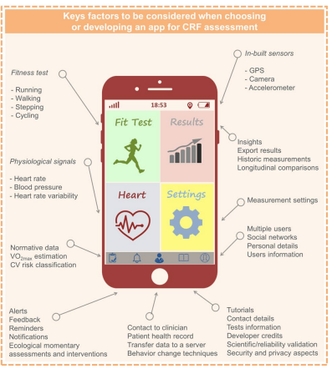

Fig 1

**3.4 Conclusion**

It’s true that technological advancement has led to some advancements in health as well as sports, however the reliability of the CRF assessment needs to be improved to show consistency in the readings. Other than that, with more and more fitness apps coming into the app store some break through is bound to happen. Thus, more and more clinics and sports facilities are going to use CRF values as a measurement to check for cardiovascular diseases as well as to train good athletes.

**______________________________________________________________________________**

1. **Project Description and Planning**

**4.1 Project/Problem Description**

Nearly 40% of American adults aged 20 and over are obese **[6]**. Our goal is to help combat this epidemic by creating an app that will help with this issue. Especially during the covid-19 pandemic, the general public has been forced to conduct their daily activities in their own homes. Due to this pandemic, they don’t require to move around that often, they tend to start becoming lazy as they are not getting their daily quota of exercise. They also end up consuming more food due to the lack of any activities. So we are creating this app to help motivate them to change their ways and make healthier decisions.

People will lose motivation after working out for a while, this can be seen when people feel motivated to be healthy in January as it’s the beginning of the year, but it is shown that the majority of the people will cancel their membership in February. The reason why our app has the milestone and reward system is so that our user will form a habit just by using our app. Our app manages to create what’s known as the habit loop that has a cue, a routine and a reward, when these three criteria are met a habit is formed. When our user forms the habit of exercising, they’re more likely to be consistent in exercising which will help combat the obesity problem.

**4.2​ ​Project Goals and Objectives**

The main goal for this project is to promote a healthier lifestyle by encouraging the user to use the app to exercise. By implementing a system where the user may receive milestones by working out according to the list of exercises that have been curated and performed by our team. The milestones will then allow the users to have discounts towards purchasing various types of sports equipment and allow the users the opportunity of achieving goals.

The prime objective of this app that we are developing is that we want to make a functional app that provides the users with a variety of workout routines that have been created by our team. We also plan to implement a timer and calorie tracker feature to help more accurately track the users progress. The next prime objective is the implementation of the milestones feature which will be keeping track of the users progress to accurately determine the reward that they deserve after reaching a certain goal.

**4.3​ ​Operating​ ​Environment**

The app is designed for Android use. This project will be developed and coded by the members of the group on their own respective hardware. Once the development process has been completed, we will submit the application to be released to most android mobile devices to be tested. The project will be created by using Android Studio and the app will be coded in Java language.

**4.4​ ​Design​ ​and​ ​Implementation​ ​Constraints​**

The design and implementation constraints for this project consists purely on the design and creation of the app. The app will have a clean and simple design that will allow the user to understand how the app functions with ease. The app must be able to perform the functions that we have listed such as the workout routine feature as well as the reward system. It should also include certain validation and verification methods, for email and password authentication during sign-up and log-in, as well as during any edit profile changes. It should also ensure only one username of its kind is registered at a time.

**4.5​ ​Target​ ​Audience**

The target demographic for this app will be for the 18 - 40 years old age group and it will cater to both male and female users.

**4.6 General Constraints**

**4.6.1 Registration**

The app functions will only be available for registered users.

**4.6.2 Language**

The app will be only in standard English.

**4.7 Difficulties**

Finding material such as images, videos, GIFs that is not copyrighted is a big challenge, that is because the vast majority of material on the internet is copyrighted and on the other hand, the workouts in the app can’t be used without an image or GIFs as a guide because most of the users do not know how each workout can be performed by themselves which will make the App not useful for them.

**______________________________________________________________________________**

1. **Group Organisation Methodology**

**5.1 Workload Division**

For this project, the workload of this software engineering project was divided and assigned to all of the members in an equal and fair manner. Our organisation methodology was that we as the entire group worked together in order to complete each section of the project requirements. The team will review the tasks at hand and one of the members will divide the workload among all the members so that the tasks will be separated in a fair and accurate method. This way we can help each other with the work as we are all handling the issues together at the same time.

**5.2 Responsibilities**

During the first group meeting, we decided on the roles as well as the group leader. For our group, we decided to opt for an organising system that involved the entire team to focus on certain tasks together so that we can overcome them with efficiency. The workload was then fairly divided and allowed the project to progress smoothly.

The group leader has the responsibility to set up the meetings as well as note down what happens in those meetings. On the other hand, one member will help conduct the meeting. This member will make sure every member is on the same page and will help divide the workload to everyone to ensure the project is on track.

Each meeting will focus on certain aspects of the project as well as reviewing previously completed tasks. We as a team decided to separate and handle the entire project into 3 different phases. The first phase will consist of idea development as well as design concepts which consist of creating the prototype concepts as well as brainstorming the functions of the app during this phase. The next phase consists of researching and information gathering which focuses on available workout routines online as well as other resources that we will use in our application. Lastly, the third phase will consist of coding and implementation which will be when we begin creating our app along with the database that we will use during the development of this app. Each member is responsible for their own workload during this project development.

**5.3 Meeting System**

There are two main types of meetings that are conducted. The first type is the formal meeting where all the students will attend along with the supervisor to discuss the progress as well as the future plans for the project.

The second type of meeting that we conduct will be the informal meetings. This meeting mainly consists of only the members of the team members. Our meeting methodology is that all the members will join 1-2 times a week to discuss the overall progress of the project as well as review each other's progress in our individually assigned workloads. All the members are advised to join every meeting held to make sure the entire group is aware and understands the progress of the project.

For the formal and informal meetings, they are all recorded in the meeting minutes that are enclosed in the Appendix E of this report. These records include the focused objectives as well as decisions made along with the attendance and anything else important that occurred during those meetings.

**5.4 Development Methodology**

The members of this group facilitate the Waterfall development method. We have determined it to be the most reliable methodology as it allows us as a group to work on certain goals before we can progress with the next phase of the project. This methodology is also quite simple to maintain as with clear goals and objectives, the entire team will be on the same page to reduce redundancy.

**______________________________________________________________________________**

1. **Requirement Specification**

**6.1 Functional Requirements**

**6.1.1 User Authentication**

* Have a sign-up page and login page for registered and non-registered users.

**6.1.2 Fully Functional**

* Create a functioning app for android smartphones.

**6.1.3 Workout Routines**

* The app should include a list of exercises for registered users.

**6.1.4 Timer Feature**

* The app should include a timer monitoring the duration of workout, which stops when the workout is finished.

**6.1.5 Calorie Tracker**

* The app should include a calorie tracker that calculates the number of calories burnt by the user.

**6.1.6 Tips Feature**

* The app should include sectionalised tips regarding fitness for the user to view.

**6.1.7 Tokens Feature**

* The app should include tokens, called FitTokens, that will be used to redeem vouchers from the Store page. The FitTokens can be earned by working out using the app.

**6.1.8 Milestones Feature**

* The app should include progress bars indicating the weekly activity of a user. The progress bars should renew on a weekly basis.

**6.1.9 Rewards Feature**

* The app should include a rewards feature that increments the tokens of the user based on the user’s Milestones.

**6.1.9 Store Feature**

* The app should include a store that contains a list of vouchers that a user can redeem with the FitTokens they have.

**6.1.10 Statistics Feature**

* The app should include a Statistics page for the user to check their number of workouts completed, rewards redeemed and total calories burnt.

**6.1.11 Settings**

* The app will have a Settings tab which will include: Edit Profile, Guide to the App, Statistics, Privacy Policy, and Acknowledgements. These will open their respective tabs with appropriate information displayed on screen.

**6.2 Non-functional Requirements**

**6.2.1 Safety Requirements**

* The app will not affect any other app installed on the user’s phone.

**6.2.2 Security Requirements**

* The app will require sign-up and login to authenticate the user.
* The app will only store the data it asks of the user upon registration.

For any project diagrams, refer to **Appendix F**.

**______________________________________________________________________**

1. **System Design and User Interface**

**System Design Diagram:**

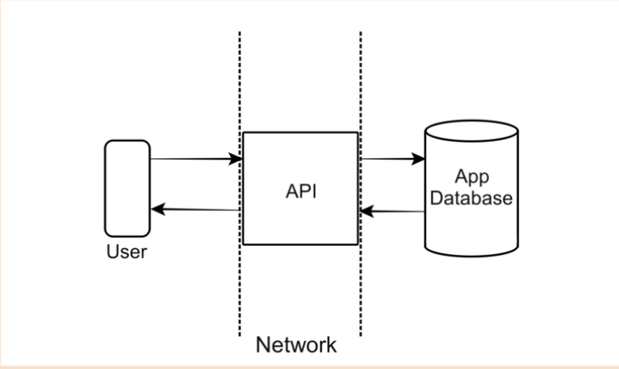

This is a very high level, abstract system design diagram. For simplicity, we excluded the extensive details of the API (Application Programming Interface).

In this diagram, the ‘User’ refers to the Users, the API refers to the application and all its functionalities, and the App Database refers to the local database that stores all the user information.

**User Interface:**

***Note:*** due to page number constraints, all images of this section have been moved to the Appendix. Please refer to Appendix A to view the UI images.

* **Loading/ Opening Screen and Registration Page**

This will be the first page that the user will come across. The app will open a Loading screen and it will then send the user to the Registration Page. On this page, the users will be able to pick one of two options which are to Sign Up or Log In.

* **Sign Up and Login Page**

In the Sign Up page, the user will be able to input their details to create an account that they can use to access the app. These details include the following: Username, Email, Password, and Re-Password. On the other hand, if the user already has an account, they can use this page to login into their accounts. They can do so by entering their username and password.

* **Home and Main Menu Page**

Once the user has logged into their respective account, they will be brought to the home page of the app. Here, they will be greeted with three quick start options which are to start a workout, visit the store page or visit the tips page that we created. These will be depicted through images and an accompanying text caption. The user can also access the main menu page by tapping the top left icon. This main menu can allow them to access all the functions and pages of the app.

These functions and pages include: Home, Workouts, Tips, Milestones, Store, Settings, Log Out.

* **Workout and Difficulty Page**

When the user selects the Workout page in the main menu, they will be brought to a page where they will be able to choose the workout that they desire. They have choices ranging from Shoulder & Arms, Back & Chest, Abs & Core and lastly Glutes & Legs. After the user selects their preferred workout, they will be greeted with the difficulty page. We offer three different difficulties starting from Beginner, Intermediate and Advanced.

* **Workout Start and Duration Page**

Once the difficulty is chosen, the workout will begin. A duration page will track the workout time as well as display what workouts the user is required to do.

* **Workout Completed Page and Store Page**

Once the user completes a workout, they will be greeted with a workout completion page that will allow the user to know how long the workout was as well as how many calories the user has burnt.

The store page is for the user to use their Fit Token that they earned through the workouts to redeem vouchers that they can use at stores.

* **Tips and Tips Article Page**

In the Tips page, the user will be able to survey many different topics based on workouts. Once the user clicks on a topic that interests them, they will be brought to the tip’s article page where they can read and learn more about the topic that they chose.

* **Milestone Tracker and Rewards Page**

This milestone tracker is where the user will be able to track whether they have achieved the milestones that we have set for them for each day of the week. If they successfully reach the goals, they will be awarded a single Fit Token for the day.

The users will be able to track their progress and rewards in the Rewards page. When the user has fulfilled the milestones, the red square will turn green indicating that they have achieved the Fit Token for the day. If the user consistently achieves the milestones, they will be able to earn bonus Fit Tokens such as 5 Fit Tokens for 4 days in a row and even 10 Fit Tokens for a whole week in a row.

* **Settings and Edit Profile Page**

In this Settings page, they can also view the guide for the app, their workout statistics, the apps privacy policy and even the acknowledgments page.

Users can also choose to edit their profile. Once they access the Edit Profile page, they can change their information such as username, birthday and email.

* **Guide and Statistics Page**

In this Guide page, the user will be able to view an in depth guide on the app and learn how to use the workout app.

In the Statistics page, the user will be able to view a statistics page that displays the user's workout completed, the numbers of rewards redeemed and the users total calories burnt.

* **Privacy Policy and Acknowledgement Page**

In this Privacy Policy page, the user will be able to read this about our apps policies.

In the Acknowledgement page, the user will be able to view all the resources, collaborators and credits towards the research and development of the app.

**______________________________________________________________________________**

1. **Key Implementations**

Regarding the implementation environment of the app, the Integrated Development Environment used to develop this app was Android Studio. Each member of the group downloaded this IDE on their respective devices and utilised it in the implementation of this app. Naturally, the technological environment of this app will require an Android smartphone to function successfully. Additionally, another technological environment within the app is the use of SQLite as the Database Management System. This database was used to store any and all user information for every individual registered user, as stated below in the back-end functionality. The implementation process also employed GitHub to be used as a private repository for backup of the app as well as to share the app with fellow team members.

**8.1 Front-end Functionality:**

Key implementations regarding the front-end functionality include:

* Login and Signup: users will have the option of either signing up as a new user, or logging in as a returning user.
* Home page: the app will include a landing page for the app with shortcut images to other pages of the app. It will also include a main menu button a user can click to access other pages of the app.
* Workout section: the primary functionality of the app includes workout routines for the full body (divided into sections) for users to perform. It will further be divided into beginner, intermediate and advanced difficulty levels. Once a workout routine is chosen, the app will display the workout name, exercise name and duration, and a timer.
* Tips section: this section serves as a motivational and educational feature for users to learn more about fitness and maximise their productivity.
* Milestones and Rewards: these pages show the weekly progress of the user, and subsequently, any rewards (FitTokens) they have earned as a result of their in-app workout activity.
* Store page: this page will provide vouchers for users to redeem with their FitTokens.
* Settings page: Edit Profile, Statistics, Guide, Acknowledgements, and Privacy Policy pages can all be accessed from here.

**8.2 Back-end Functionality:**

Key implementations regarding the back-end functionality include the database information of all the registered users. The information includes User ID, Username, User Email, User Password, User Date of Birth, User Progress (Statistics and FitToken count), and weekly User’s Milestone and Rewards progress. Users can access their account by logging in, and data from the app’s servers will be used to authenticate and verify the user, allowing them to login based on the authentication status. The backend will also include the increment and decrement of the FitTokens, based on the activity of the user according to their Milestones and Rewards data, and their purchases in the Store, respectively. Furthermore, the system to manage the workout information, videos, gifs and images used throughout the app will be managed through the backend. A database for all the workouts of the app is also present for the administrators to remove, add or modify any workout routine, as well as any coding for the layout for the creators to modify the appearance or design of the app.

**8.3 Implementation Changes**

***Note:*** due to page number constraints, all images of this section have been moved to the Appendix. Please refer to Appendix B to view the Implementation Changes images.

Group members discussed and decided upon implementing certain key changes to the app, such as:

* **UX Design:** for increased ease of navigation and accessibility through the app, all key buttonsare relocated under the Main Menu button.
* **Store:** instead of having direct online purchases of items from stores, an alternative of vouchers was created and added which users can redeem with their Fit Tokens, and use the redeemed vouchers to buy discounted sports’ items from local stores (physically).
* **Contact information:** for additional enquiries a user may have, they can choose to contact the app’s admins through the information provided under ‘Guide to Fit Garage’ section.
* **Tips:** to ensure users can view what they’re interested in, similar tips are sectionalized under appropriate titles instead of being randomly generated.
* **Profile picture:** for increased security, users do not have to upload a profile picture.

**______________________________________________________________________________**

1. **Testing/Evaluation**

The app was built on Android Studio, and upon every implementation, from fundamental skeleton to the final product, was run and evaluated thoroughly to ensure it was fully functional, before moving onto the implementation of the next step.

The app was built by, initially, segregating the entirety of the app into separate sections: Home, Workouts, Tips, Milestones, Store, and Settings. These sections of the app were created and run by respective group members to whom the task had been assigned. Upon positive results from running the app on the emulated phone, implementaion was approved and compiled with the main version of the app. This was repeated until group members had contributed and compiled a full version of the app. The full version was subject to final editorials for any errors, inconsistencies, designs, or any changes group members felt appropriate to improve the final version.

The final version of the app was rerun one last time and uploaded to GitHub, as well as on Cloud storage for group members to access, and for backup purposes.

For the Test Suite of the final version of the app, refer to Appendix D.

**______________________________________________________________________________**

1. **​Time​ ​Plan​**
   1. Original Time Plan

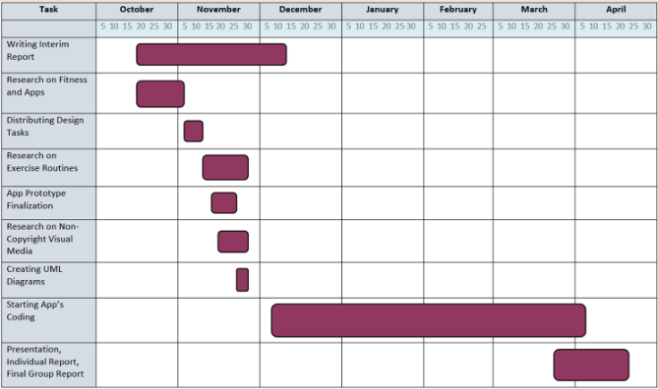

* 1. Final Time Plan

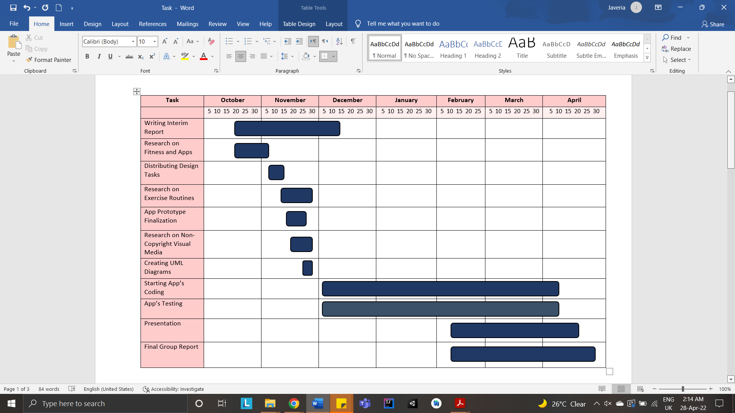

**______________________________________________________________________________**

1. **Summary of Achievements**

In regards to what we were able to accomplish, it is noteworthy that the group was able to achieve almost all of the stated functional and nonfunctional requirements.

As stated in the functional requirements, first-time users can sign up for the app, which will register the user and create an account for them, and registered users can login to the app. The app is also fully functional on android smartphones, and contains a list of exercises for registered users of varying levels of difficulty. The workout app also will be able to display workout videos guiding the user throughout the workout routine. The workout feature includes a timer which monitors the duration of the workout, as well as a calorie tracker that keeps track of the amount of calories a user has burnt while exercising using the workout routines in the app. To encourage users, there is a Tips page, which includes various research-based articles that a user can read through to maximise their productivity. The app also includes tokens that a user earns based on their progress, and their weekly progress is stored in the Milestones page. A Rewards page within the Milestones page checks the user’s progress and increments the FitTokens. A Statistics page that logs the number of workouts a user has completed using the workout routines in the app, amount of Rewards redeemed through the Store, and total count of calories burnt. There is a Settings page, which includes Edit Profile, Guide to the App, Statistics, Privacy Policy and Acknowledgements for the user to peruse.   
  
For Non-functional requirements, the app will authenticate and match a user’s username and password with the one stored in the system, and notify the user if their credentials are invalid.

The app will also assign the user an ID number according to the order that an account is created.  
Other non-functional requirements have not been verified, as they require the app to be installed on the phone.

During implementation, the group decided on certain changes that we deemed would be far better in terms of user-friendliness and overall user experience. These changes have been listed under the Key Implementations section.

**______________________________________________________________________________**

1. **Discussion and Conclusion**

**12.1 General**

As the purpose of this group project is rather straightforward, we still manage to figure out a way to implement a rather simple app into something unique. We manage to create a fitness app in a way that allows new users easy access to our app, as well as keep them engaged and motivated.

Normally fitness apps have videos to teach users or beginners how to do a specific exercise, however this is rather bland in keeping users motivated. Since the whole point of a fitness app is to allow users to do workouts at home and be motivated to exercise more, our group created a milestone and reward system to do just that.

With this milestone and reward system, we should be able to keep the users more engaged in exercising and having a healthy lifestyle. The milestone implemented can help users to get new exercise equipment at a slightly cheaper price which can motivate them more. Furthermore, we encourage our users to work out for at least 30 minutes a day, thus our app uses a timer and a progress bar to show their daily quota of exercise. Along with a daily counter which rewards users for exercising a few days in a row, users will develop a habit for exercising.

One of the major struggles that our group faced was finding open source tutorials on the simple exercise made. Since we have to find videos to help beginners with their exercise, we need to have a short video or clip to guide them so they perform the exercise without hurting themselves. Most of the high definition (HD) videos we found were not open source. In contrast, the videos we managed to find weren’t providing useful information.

We went with a simplistic design so that new users can have a much easier time using the app. The app is very intuitive, so users won’t have trouble figuring out how to use it. The final design was chosen out of a few prototype design layouts we had. Initially, the workout was supposed to be chosen by the user instead of the routine system we have in the end. This meant that the users would have been able to choose their own workouts in a routine. However, through further discussion with our supervisor, our group decided on the routine system as this allows users to get into their workout as soon as possible. The routine is separated into 3 different levels such as beginners, intermediate, advanced to give more options to the users who want a beginners routine or a challenge.

In a nutshell, our group has conducted a series of discussions in moulding the app you see now. Through rigorous testing and tweaking, this app is the best version after a series of modifications. It is now a simple fitness app that motivates its user to exercise more and rewards them for doing so.

**12.2 Software Evolution**

To further improve the interface and functionalities of the app, our plans to improve the app in the future include:

* **Communication functionality:** This feature will allow users to communicate with each other. It will utilise a forum where users can create posts and comment on them. It will also allow posting of pictures for users (photos will be verified to ensure they are within application guidelines).   
  It will be beneficial for: new users learning about the app and fitness in general, and to get a feel for the app’s local community; general support and motivation for registered users, as other users will be able to comment and encourage them (please note that any negative comments or language use against the apps’ guidelines will be deleted); challenge reports for users to share their progress using regular reports, which serves as motivation for them and other community members; educational purposes, where users can post a topic on a matter they would like to learn more about, and other users can share what they know from their experience; personal tips and user experience share, where users can share their journey and what they learned with other users, and share any tips that may not be available in the tips section.
* **Increased Security:**  As users will be sharing more personalised data, the app will improve its security measures.
* **Increased number of workouts:** To increase variety, more workouts will be added to each section of the difficulty level list. Upon clicking on a difficulty level, the user will see a page with lists of numerous workouts they can choose to perform within that sectionalised body area.
* **Cloud Storage:** The app will transition its storage system from (presently) SQLite, to a cloud-based storage system. This is to allow the users to be able to use the app on any device and still be able to retain their data and progress.
* **Workout Plans:** These will be pre-packaged lists of workout routines to be performed by a user. They will cater to a certain goal; for example, a user wants to strengthen their upper body. The workout plan, titled ‘Strengthen Upper Body in 6 Weeks’, will be created such that the user starts by performing simple, beginner level exercises, and gradually over the course of the specified time, they will progress from beginner level exercises to more advanced variations. There will be many plans available for users to choose from and perform. A user will only be able to join one plan at a time for health reasons.
* **Report user option:** While the app will ensure the removal of any offensive language, racial or religious slurs, and any other negative remarks, there is still a possibility of poor behaviour undetected. Users facing these will have the option of reporting the user guilty of this negative behaviour. Administrators of the app will check through the reported activity and confirm if the user is indeed guilty. Guilty users will be informed of their strike number, and if they reach strike 3 (if a user is reported three times for offensive behaviour), their account will be suspended for a certain amount of time. If the user continues this behaviour after the suspension is lifted, their account will be permanently deleted.
* **Accelerator:** To ensure no user cheats their way into earning FitTokens, the app will utilise smartphone accelerators to detect user movement. When the user presses ‘Start’ on workout, the accelerator will start monitoring when the user is exercising. The monitoring will end when the user has reached the ‘Completed Workout’ page. This feature can also help us track the users steps which can allow us to implement more cardio oriented workout routines into our app.
* **Accessibility:** For Accessibility purposes, the app will include:
* display options, such as bold text, larger text, smaller text, change button shapes,
* change appearance, such as dark mode, grayscale, invert, sepia, increase or decrease contrast, differentiate without colour, colour filters, reduce white point.
* voice control: users will be able to navigate the app using their voices with this option. Users will be able to use this with any language (they have to select a language first).
* **Languages:** For diversity purposes, the app will be made available in all languages of the world. On the registration page itself, users will see a ‘Select Language’ option at the bottom of the page. Upon clicking, users will be able to select a country, and one of its language variations that it includes.
* **Profile picture settings:** Due to inclusion of a forum communication, users will be able to choose a profile picture. This feature will not be mandatory for all users, so that the users can choose to not have a profile picture as well.
* **Private profile:** Users will be able to set their profiles to private to keep their data confidential.
* **User Minutes:** Users’ profiles will display their workout minutes for the other users to see. This feature can be turned on or off.
* **Forgot Password:** Users will be able to reset password by clicking on this button, receiving an email from administrators on their email account provided upon sign-up, and use the new password provided by the administrators.
* **Change Password:** users will be able to change password in Settings, Edit Profile. This option will require the user to enter their current password, and upon successfully entering their current password, they will be able to enter their new preferred password. This feature will include password matching verification as well, to ensure the user's new password is accurately entered.

**______________________________________________________________________________**

1. **Reflection on the Success of the Project**

**Technical Perspective:**

For the reflection on the technical aspect, it proved to be quite a challenge to develop an app in Android Studio. This was because all of the members, at first, had not had any experience with developing a mobile application or even any experience with Android Studio. Keeping this in mind, team members held a thorough discussion on alternative choice apps and coding languages that we preferred, as a majority, otherwise. The group chose to work with Android Studio collectively. Following this decision, all members took time after the initiation of the implementation process to familiarise themselves with this IDE. On top of that, as a consequence of condensed user requirements, the early stages of implementation were unhurried, as the team took time outside to research on additional functionalities to include.

However, as the implementation progressed and the team saw tangible results, the implementation process sped up. This was largely owing to the clarity the team beheld in terms of what there was to achieve, as well as more familiarity with the app, and the time limit.

Towards the final stages, the implementation tempo was at its peak as the team compiled the full app and performed error-checks, together with overseeing any touch-ups required.

Ultimately, the team managed to achieve almost all user requirements, system requirements and functional requirements, within the deadline. The team deemed this a satisfactory success. Any functionality that the team was not able to achieve (of which there was only one), the team noted it down to be added to the app during the evolution phase of the software development.

**Project Management Perspective:**

To begin, the initial progress of the group work progressed quite slowly as we took slightly more time to decide a group leader. However, once the group leader was properly elected, the progress continued at a steady pace towards our goals. In the earlier stages for the group project, we still hadn’t understood each member's strengths and weaknesses. Later on through the project, we were able to properly divide the workload based on each other's strength as we were now more familiar with each other. This allowed for the app to be developed more smoothly, and also ensured that each element of our project was done to its highest quality.

Unfortunately, we encountered a steep challenge near the beginning of the project timeline which was that a group member decided to not respond during the planning and research phase. This caused the group number to reduce and thus the workload to increase for all of the members for the project. However, through some restructuring, we were able to manage the workload considerably and allowed the team to work on the project at a constant rate.   
 Though it is noteworthy that in spite of our positive and steady progress, the team continually tried, to the best of their ability, to engage this team mate into communication and, as a result, into the project. The team also ensured this group member was welcome and communicated with him in a positive light. Unfortunately, the team still did not receive contact from this group member.

In the end, despite this hurdle, the team managed to successfully meet all requirements by frequent communication and equal support.

**______________________________________________________________________________**

**References**

**1.** “Fitness App Market Size, Share & Growth Report”, Jan, 2021. [Online]. Sample Available: https://www.grandviewresearch.com/industry-analysis/fitness-app-market . [Accessed: 06-Nov-2021]

**2.** Regina Guthold, Gretchen A Stevens, Leanne M Riley, Fiona C Bull. *Worldwide trends in insufficient physical activity from 2001 to 2016: a pooled analysis of 358 population-based surveys with 1·9 million participants - Vol 6 -* October 2018. [Online]. Available from: https://www.thelancet.com/action/showPdf?pii=S2214-109X(18)30357-7 .

[Accessed: 06-Nov-2021]

**3.** Tiahn Wetzler. *COVID-19 lockdowns accelerate growth for health and fitness apps.* Weblog. [Online] Available from: https://www.adjust.com/blog/health-fitness-apps-2020/ [Accessed 08-Nov-2021]

**4.** Jackie Davalos. *How Covid-19 Has Permanently Changed the Fitness Industry.* [Online]. Available from: https://www.bloomberg.com/news/articles/2021-01-19/fitness-industry-may-never-return-to-its-old-ways-after-covid-19

[Accessed 16-Nov-2021]

**5.** Synopsys Editorial Team. (2021, July 28). *Top 4 software development methodologies*. Software Integrity Blog. <https://www.synopsys.com/blogs/software-security/top-4-software-development-methodologies/>

**6.** Team, S. (2021, January 21). *Overweight and obesity statistics 2021*. The Checkup. https://www.singlecare.com/blog/news/obesity-statistics/

**________________________________________________________________________**

**Appendix A: User Interface Images**

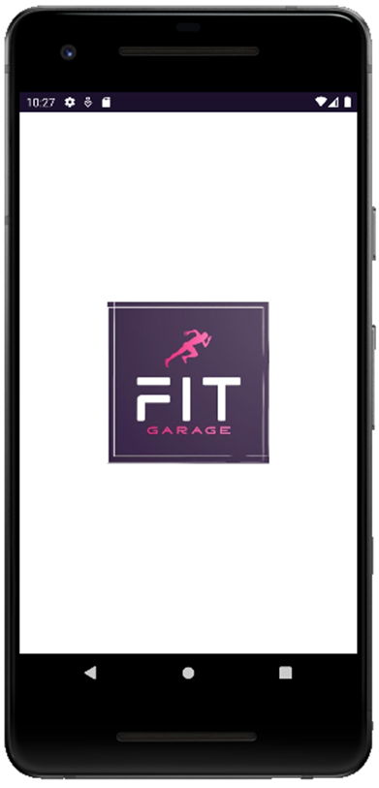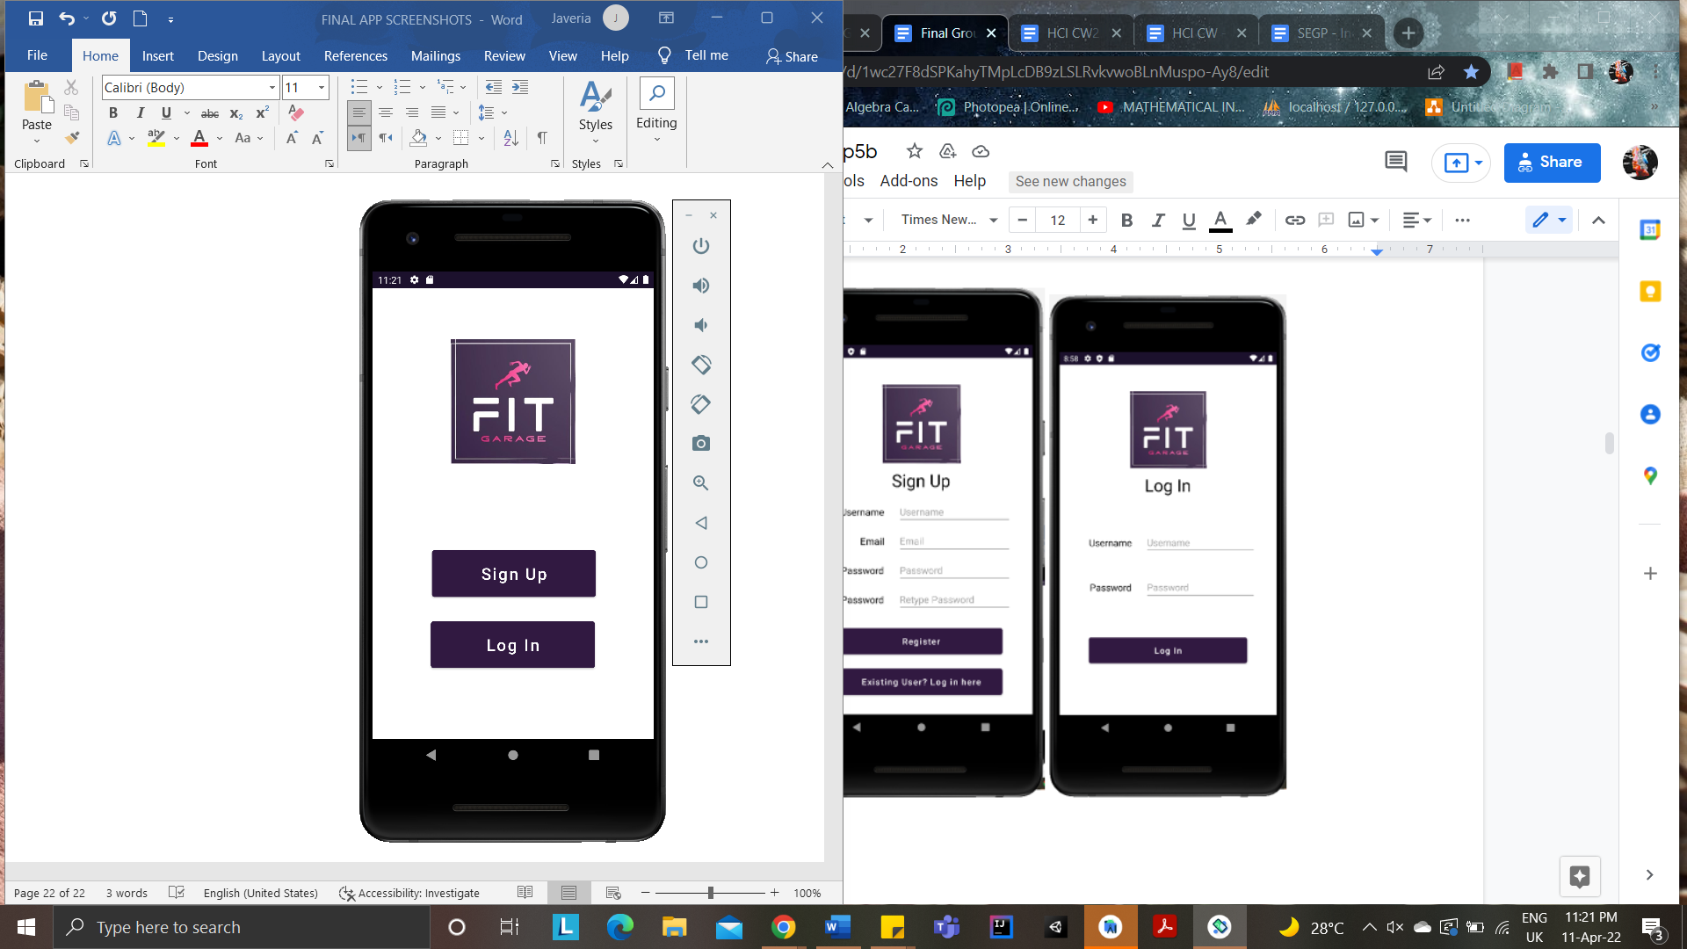

*Loading/Opening screen**Registration Page*

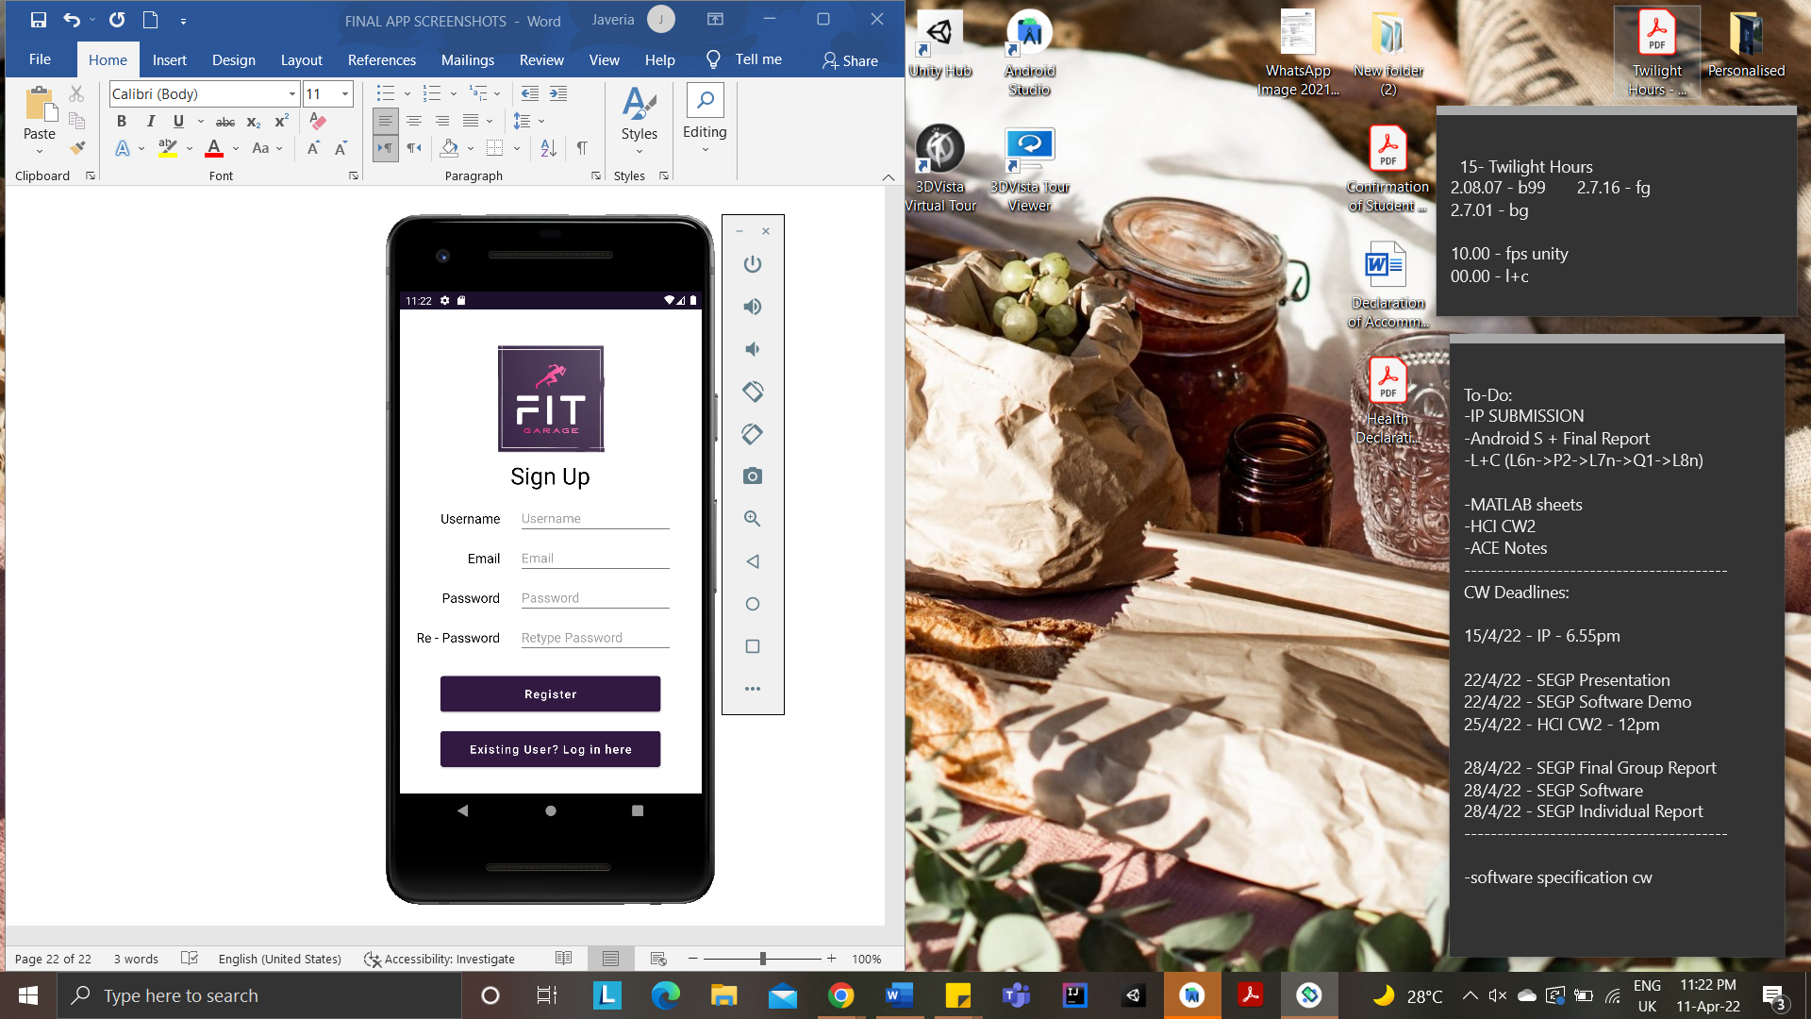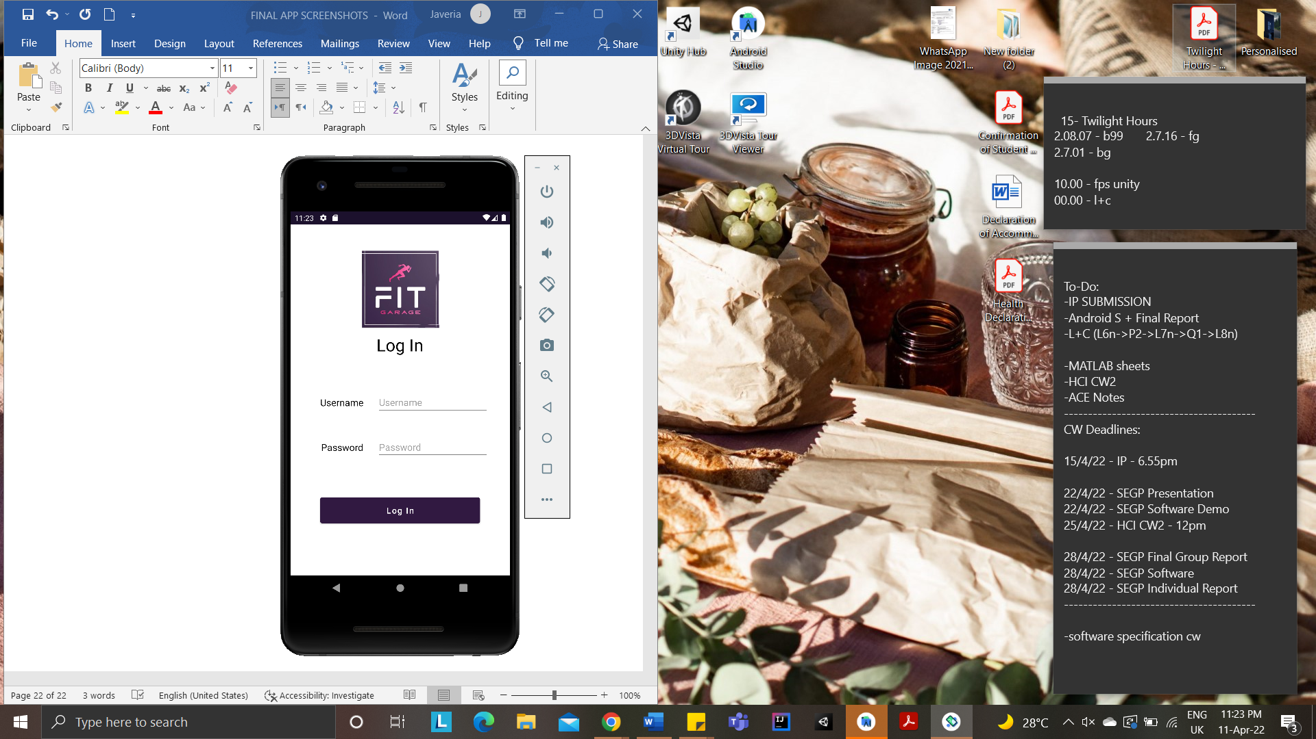  
*Sign Up Page Login Page*

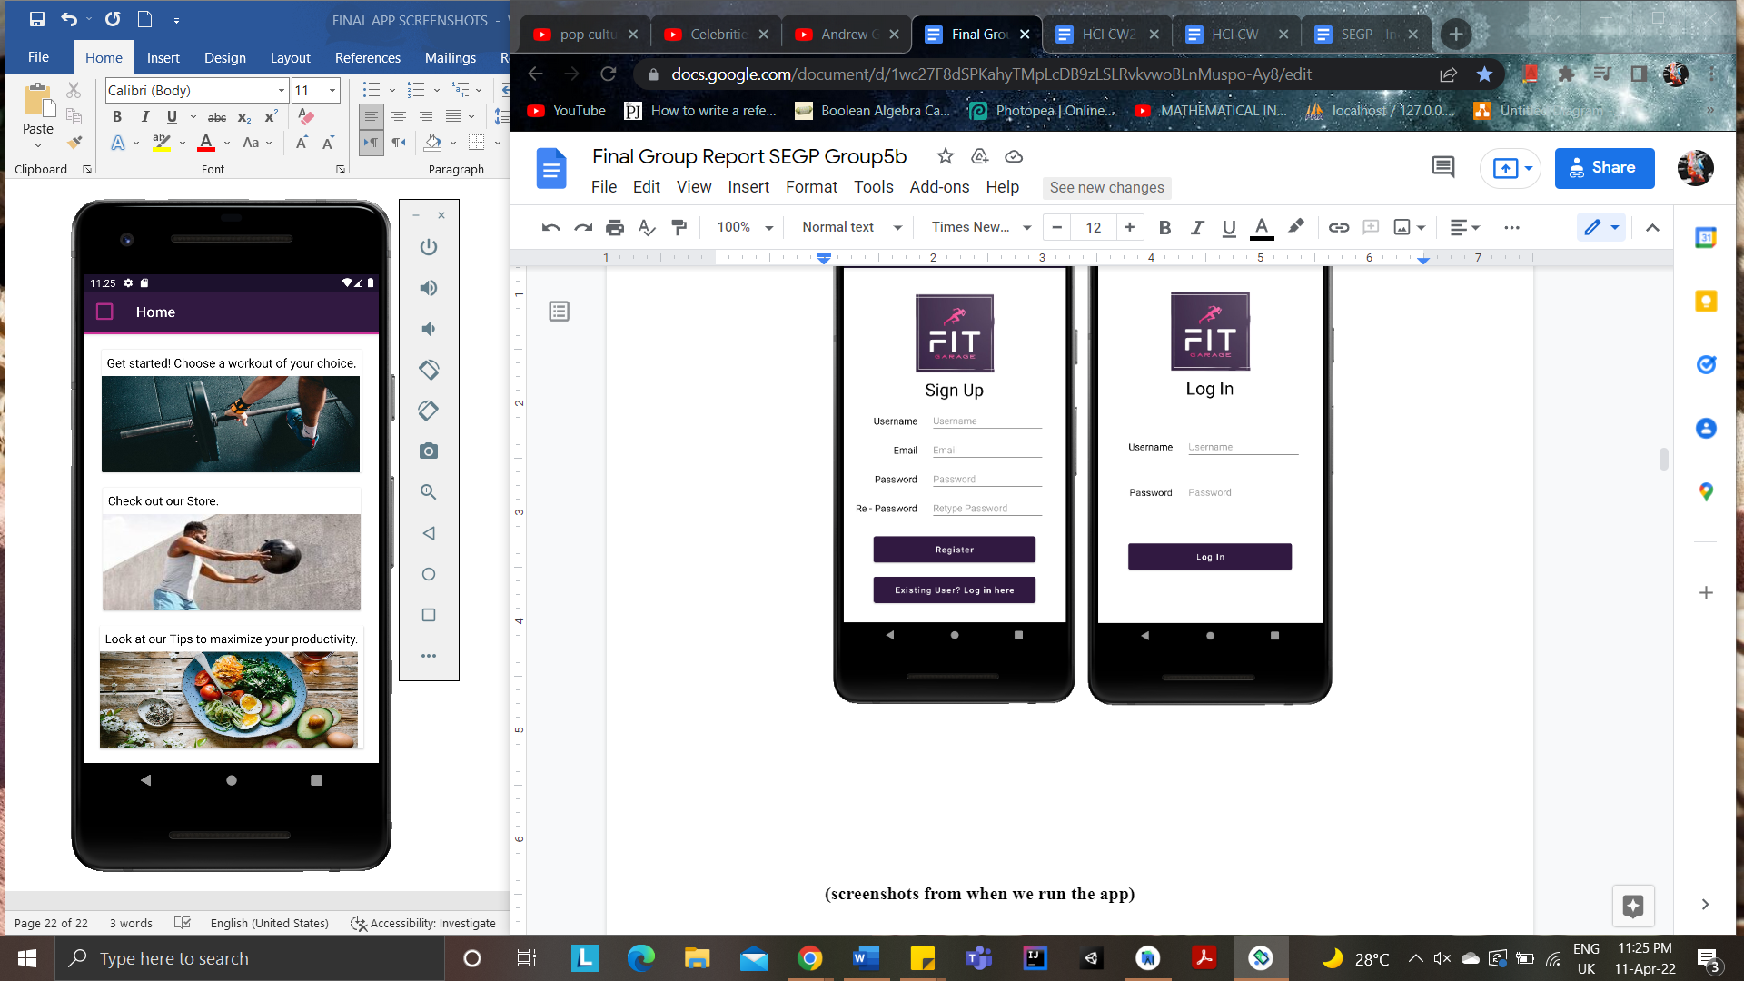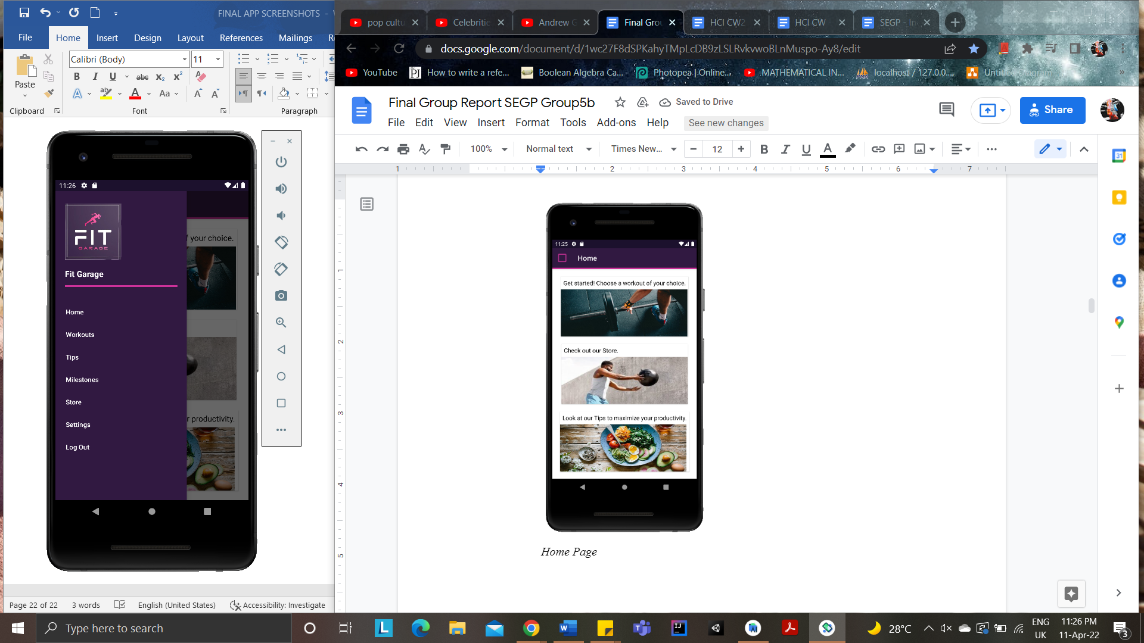  
*Home Page Main Menu Page*

*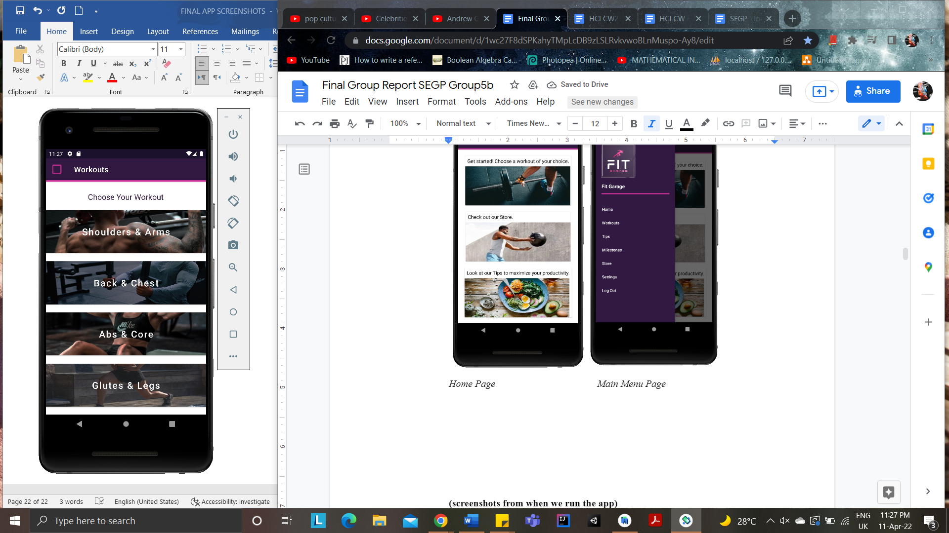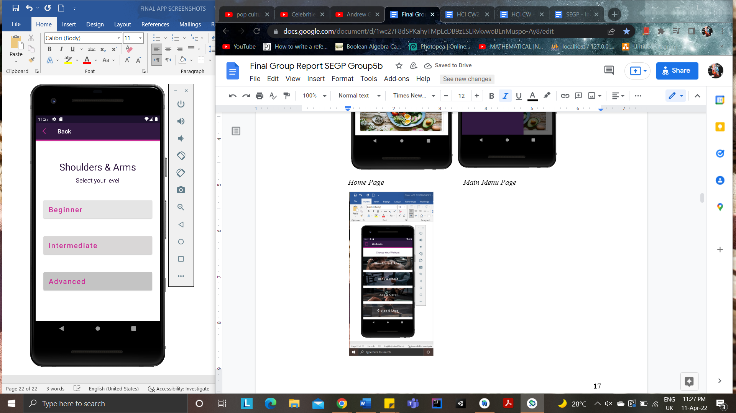  
Workouts Page Difficulty Level Page*

*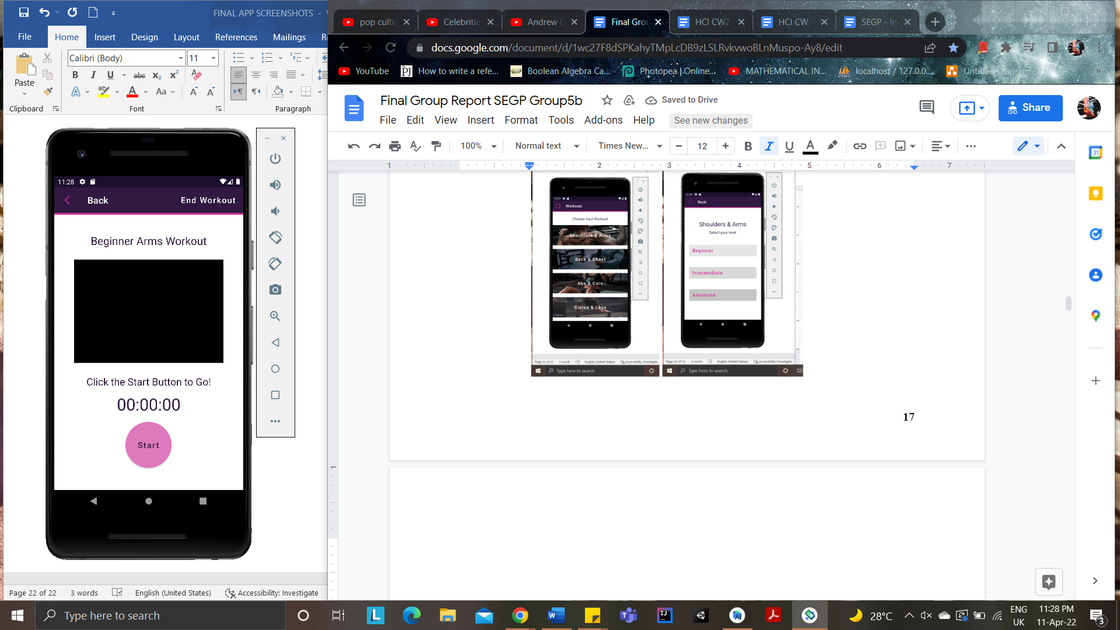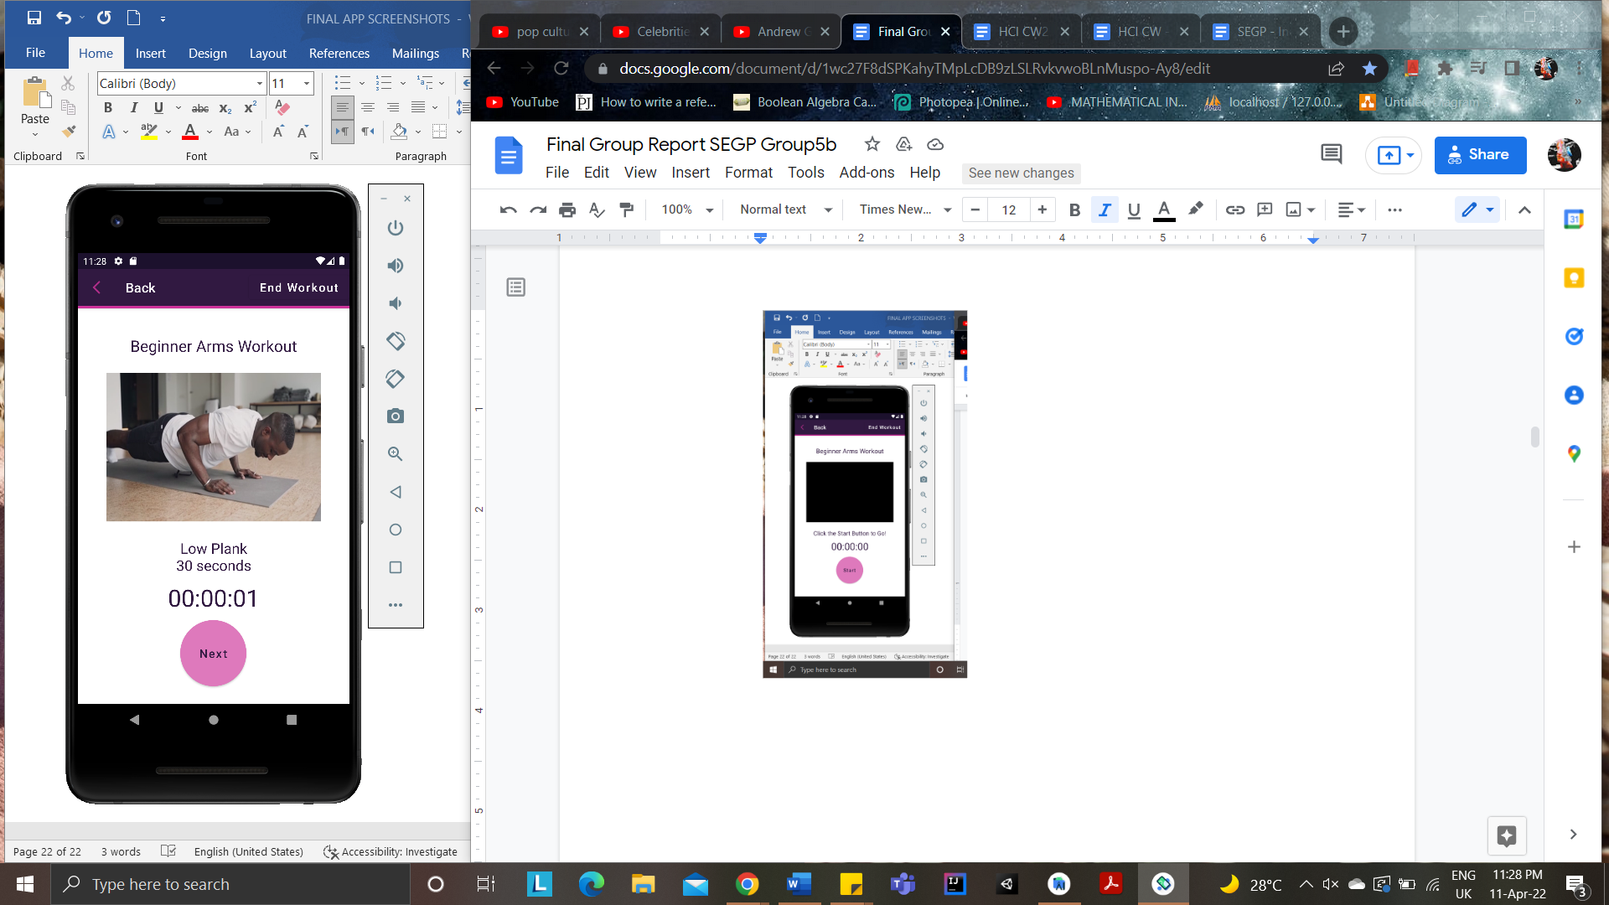  
Workout Start Page Workout Duration Page*

*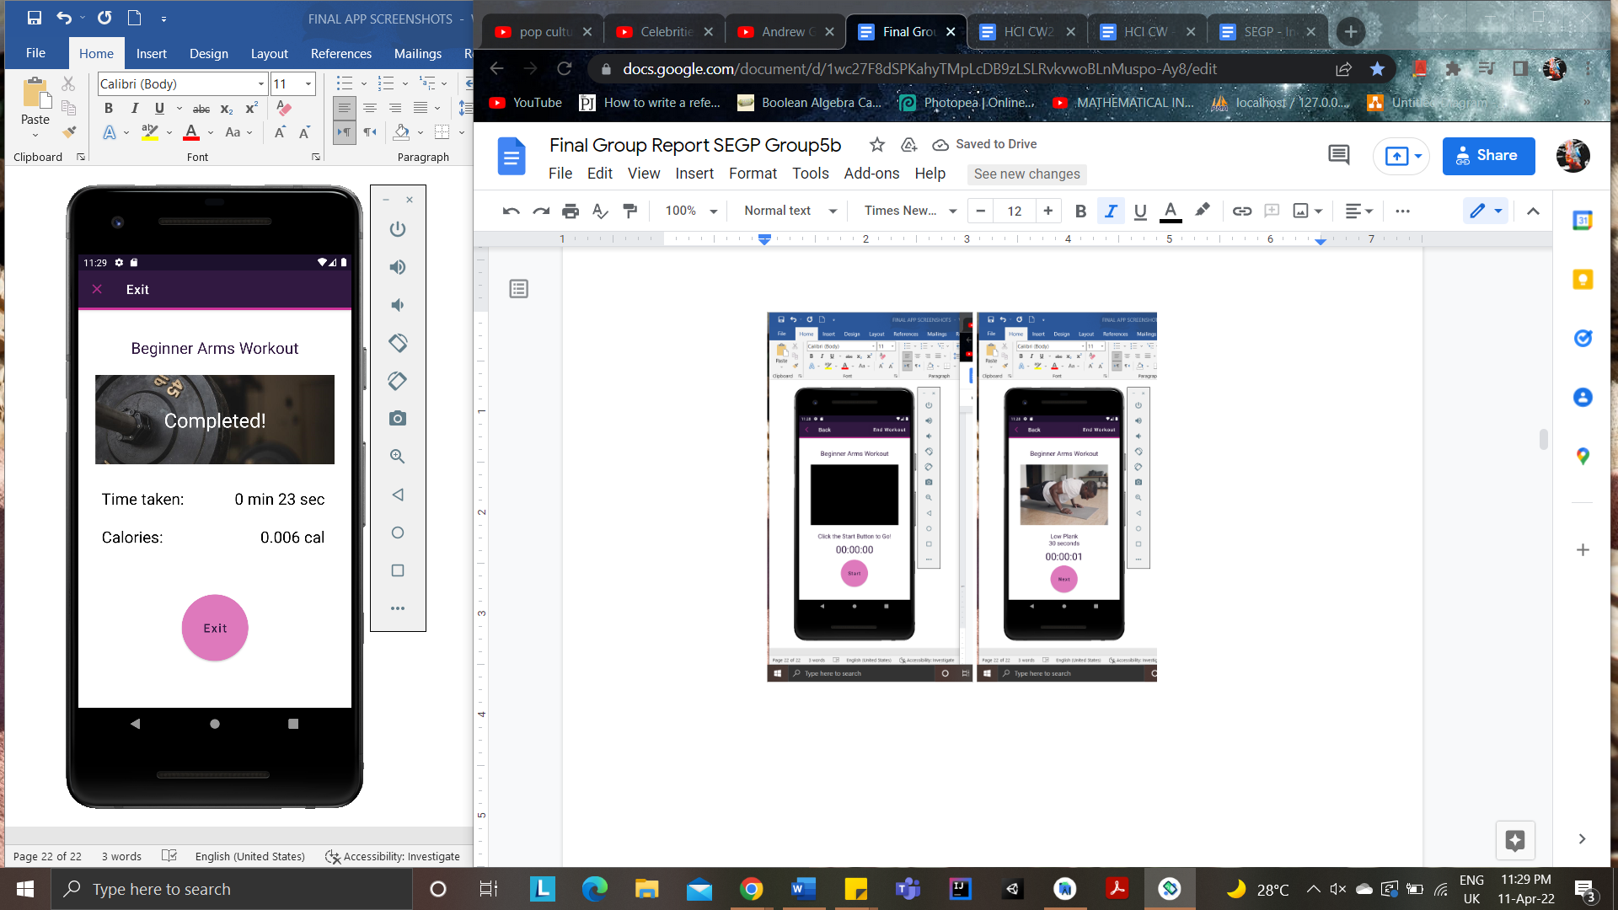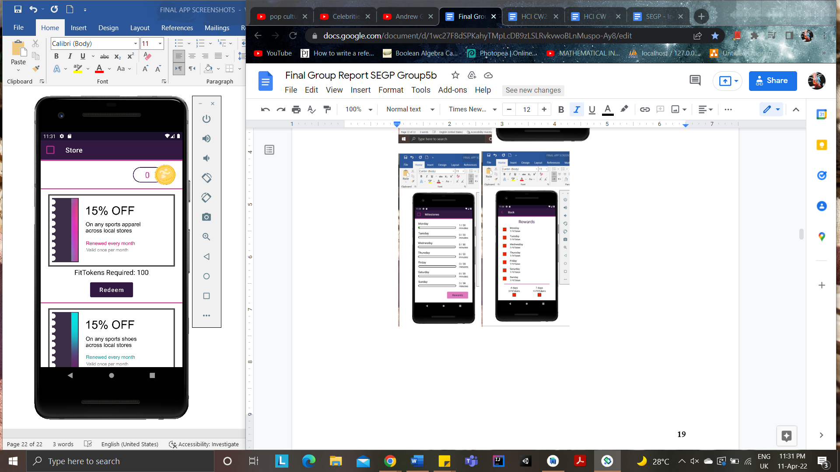  
Workout Completed Page Store Page*

*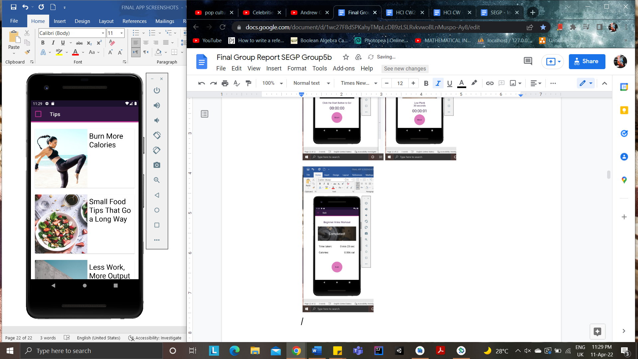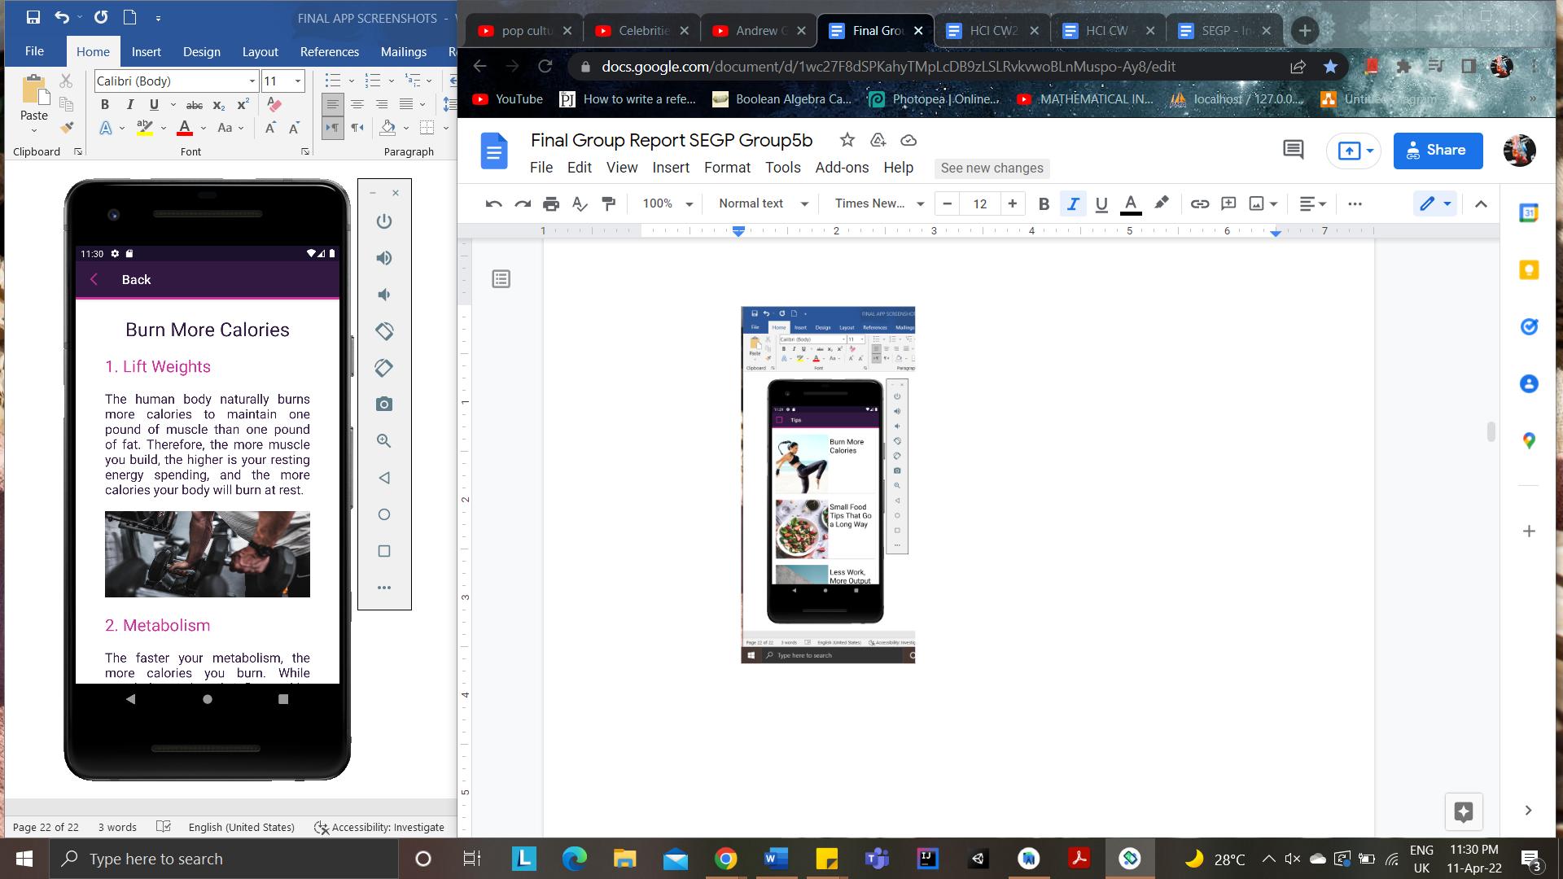  
Tips Page Tips’ Article Page*

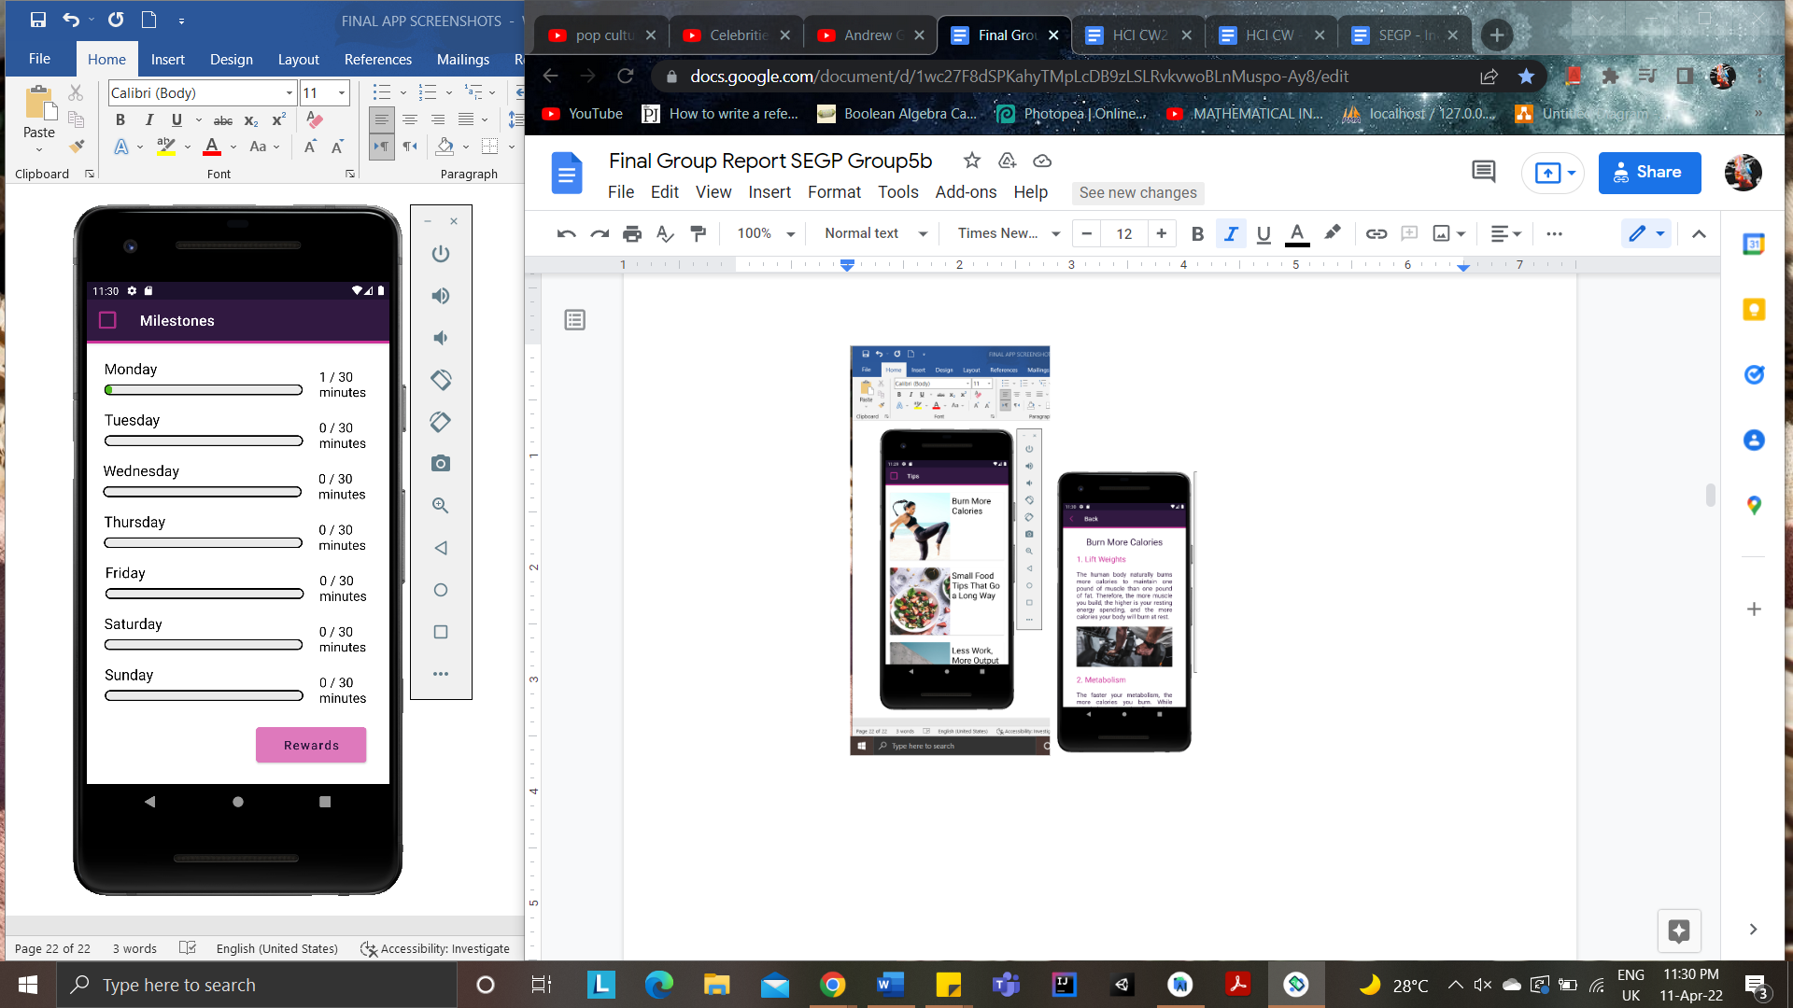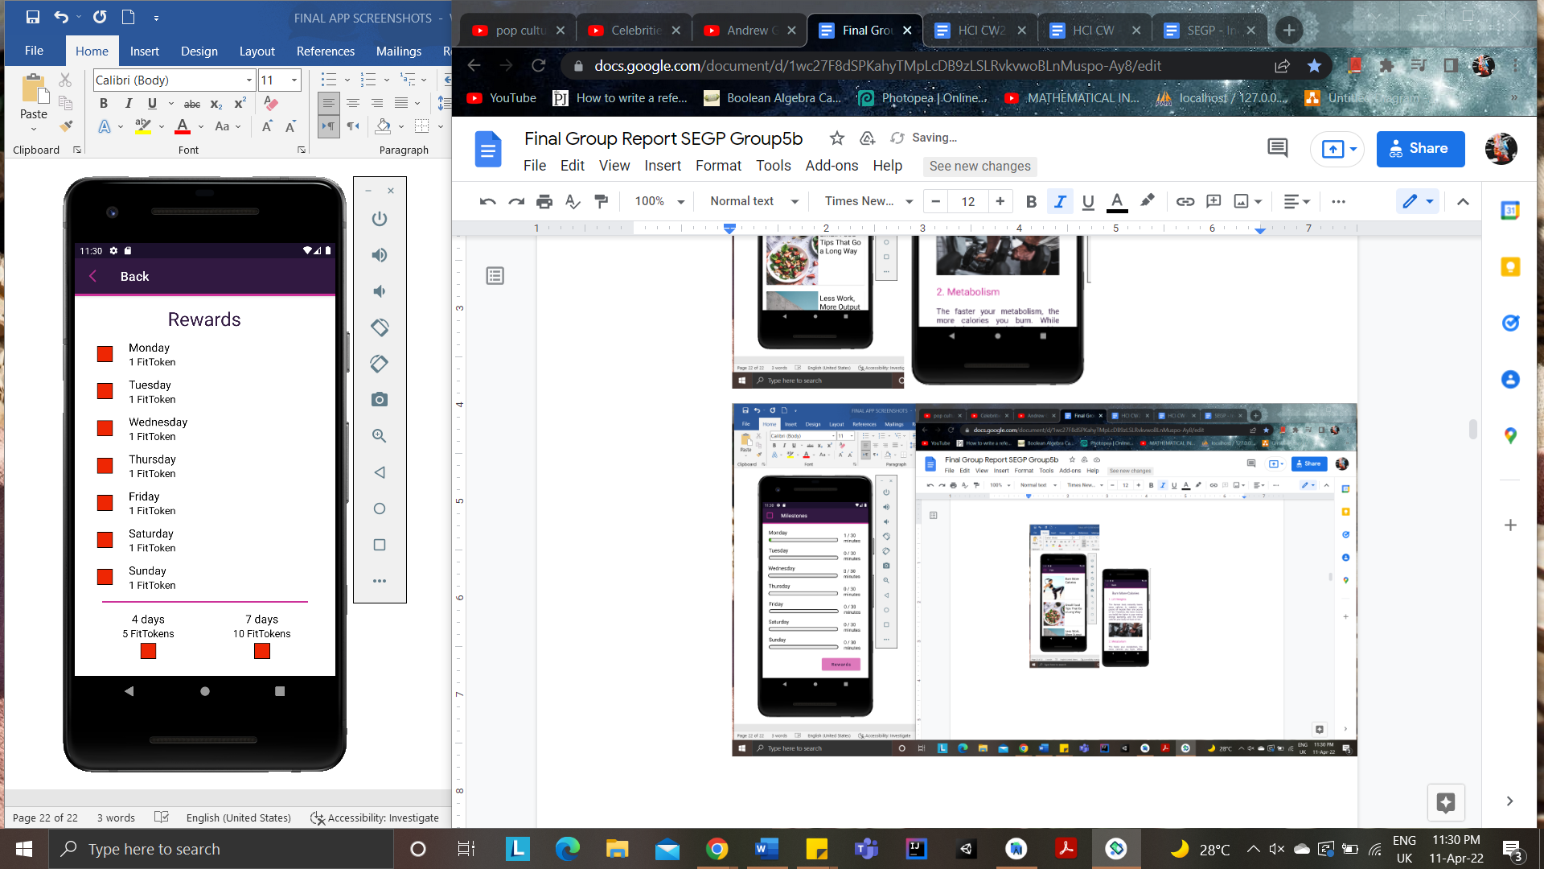

*Milestones Page Rewards Page*

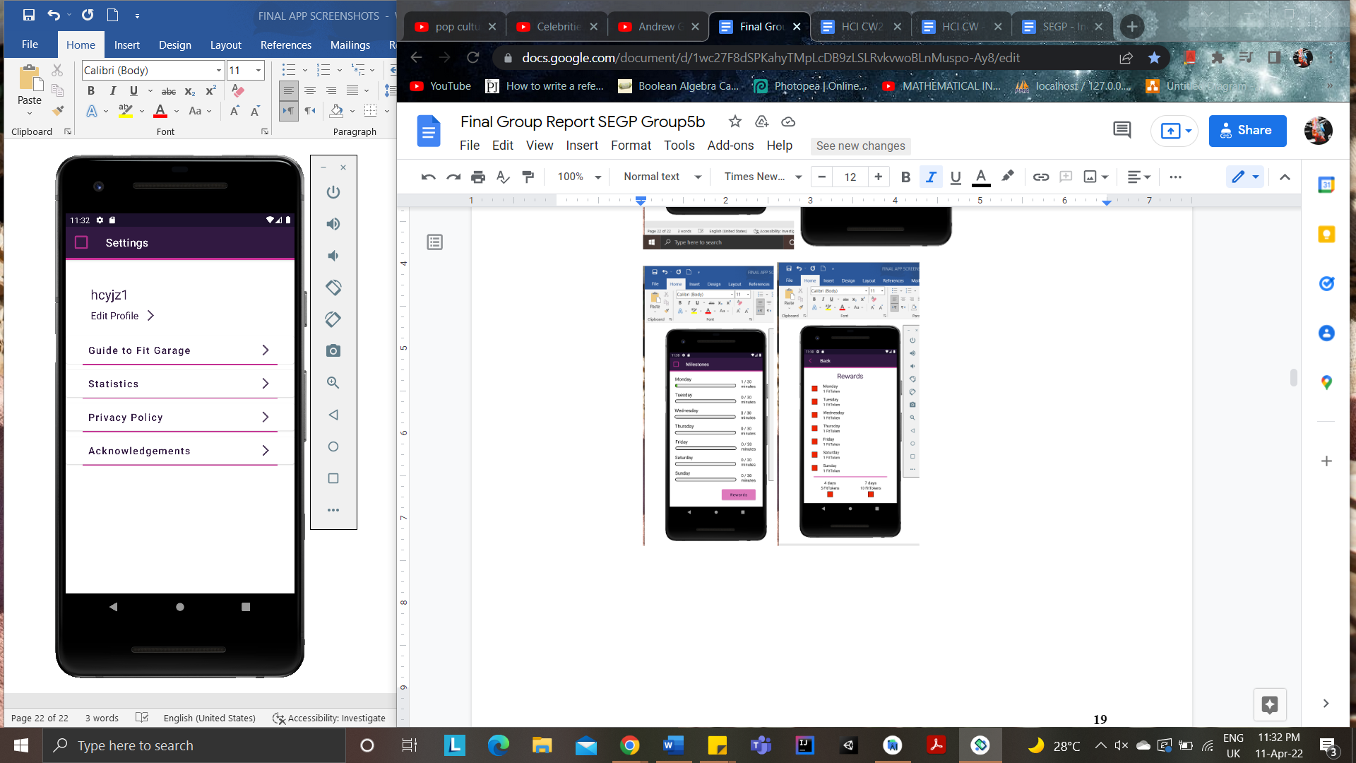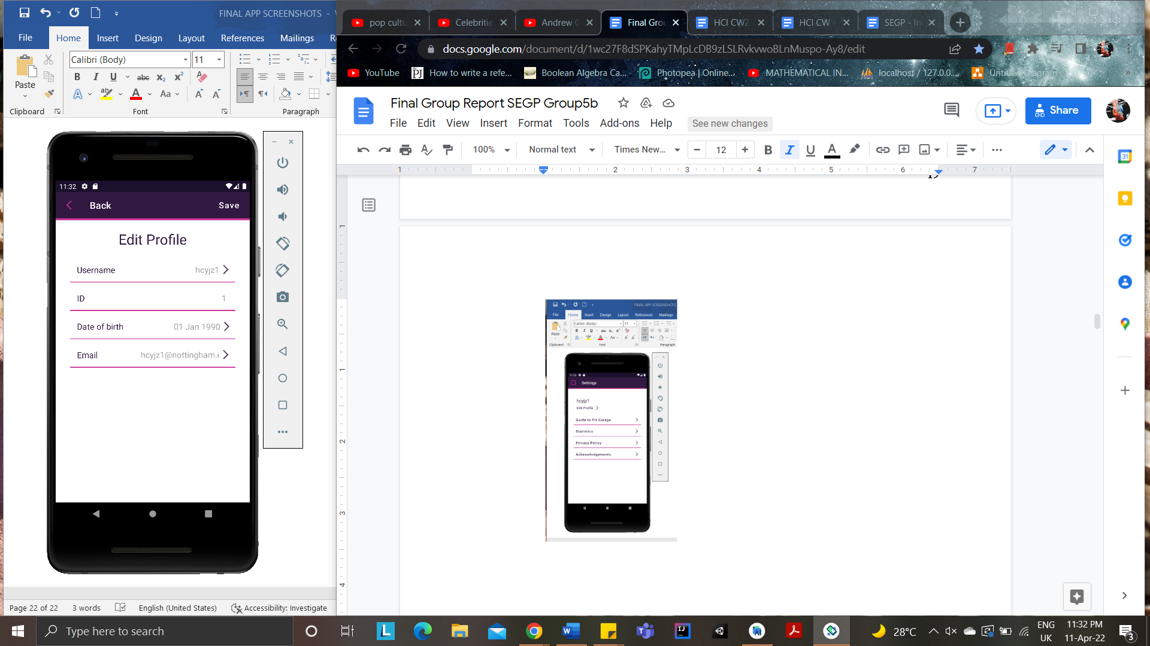

*Settings Page Edit Profile page*

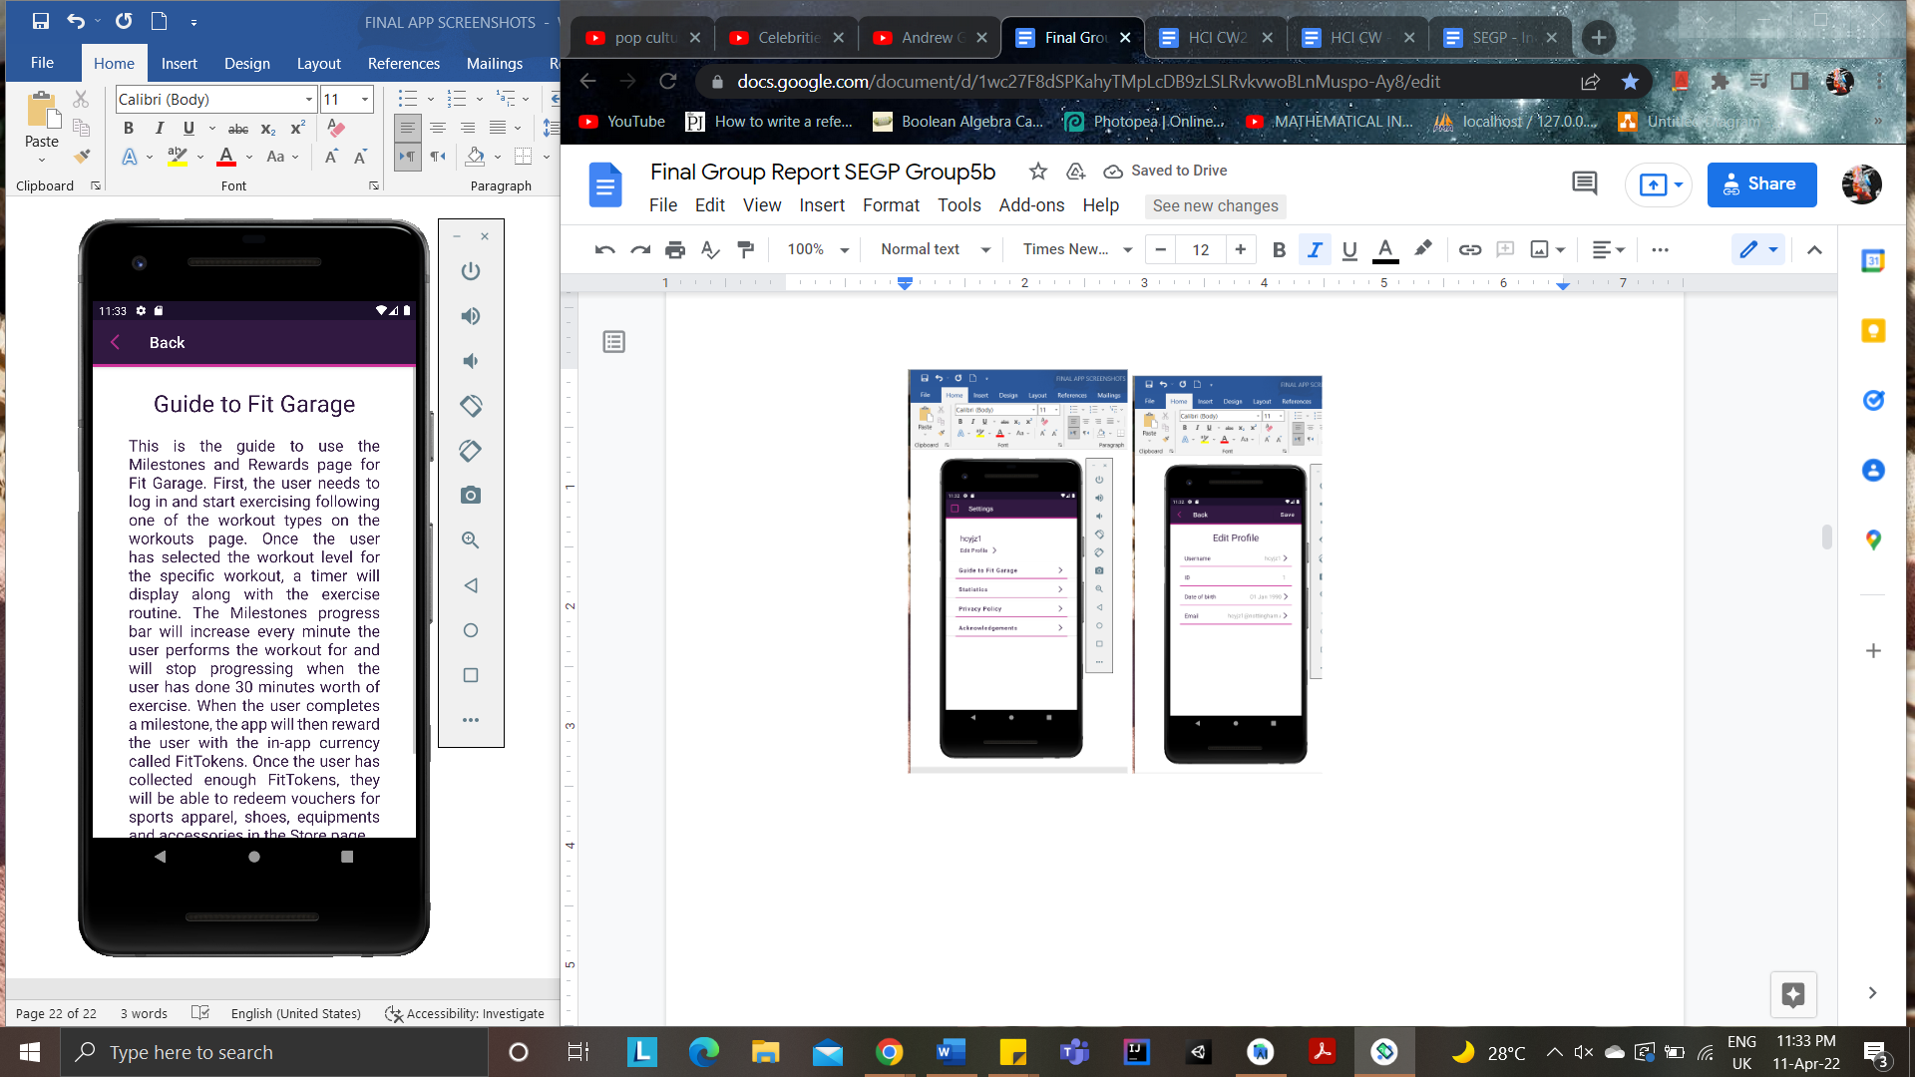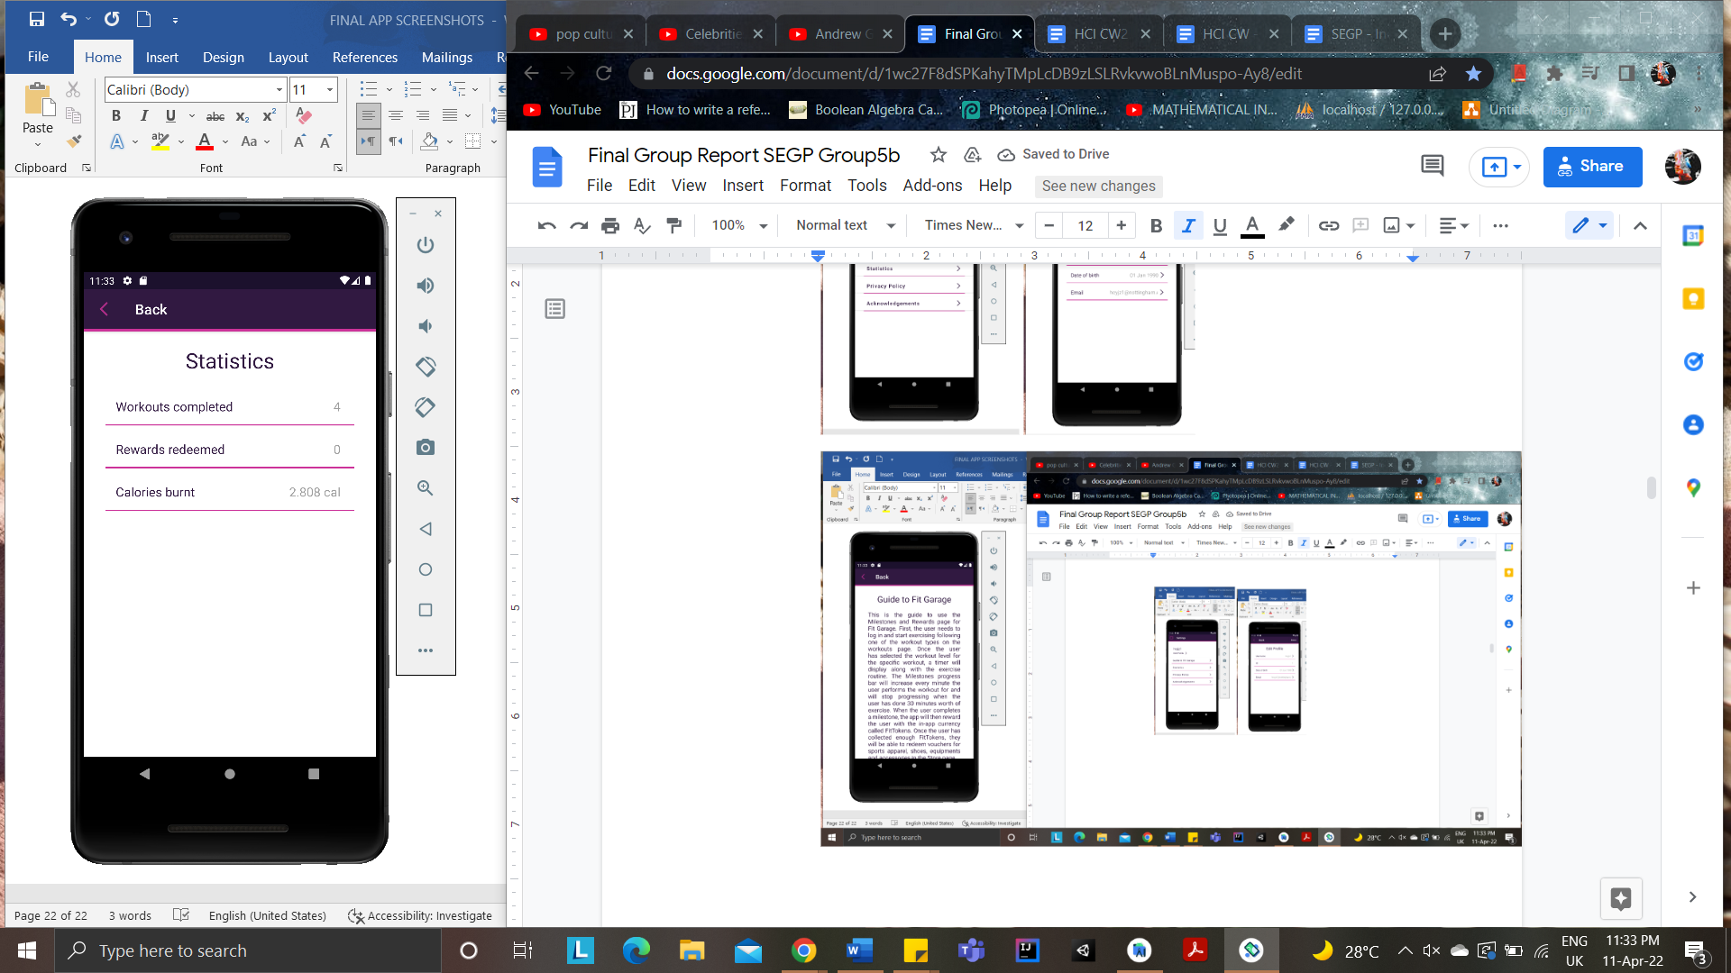

*Guide Page Statistics Page*

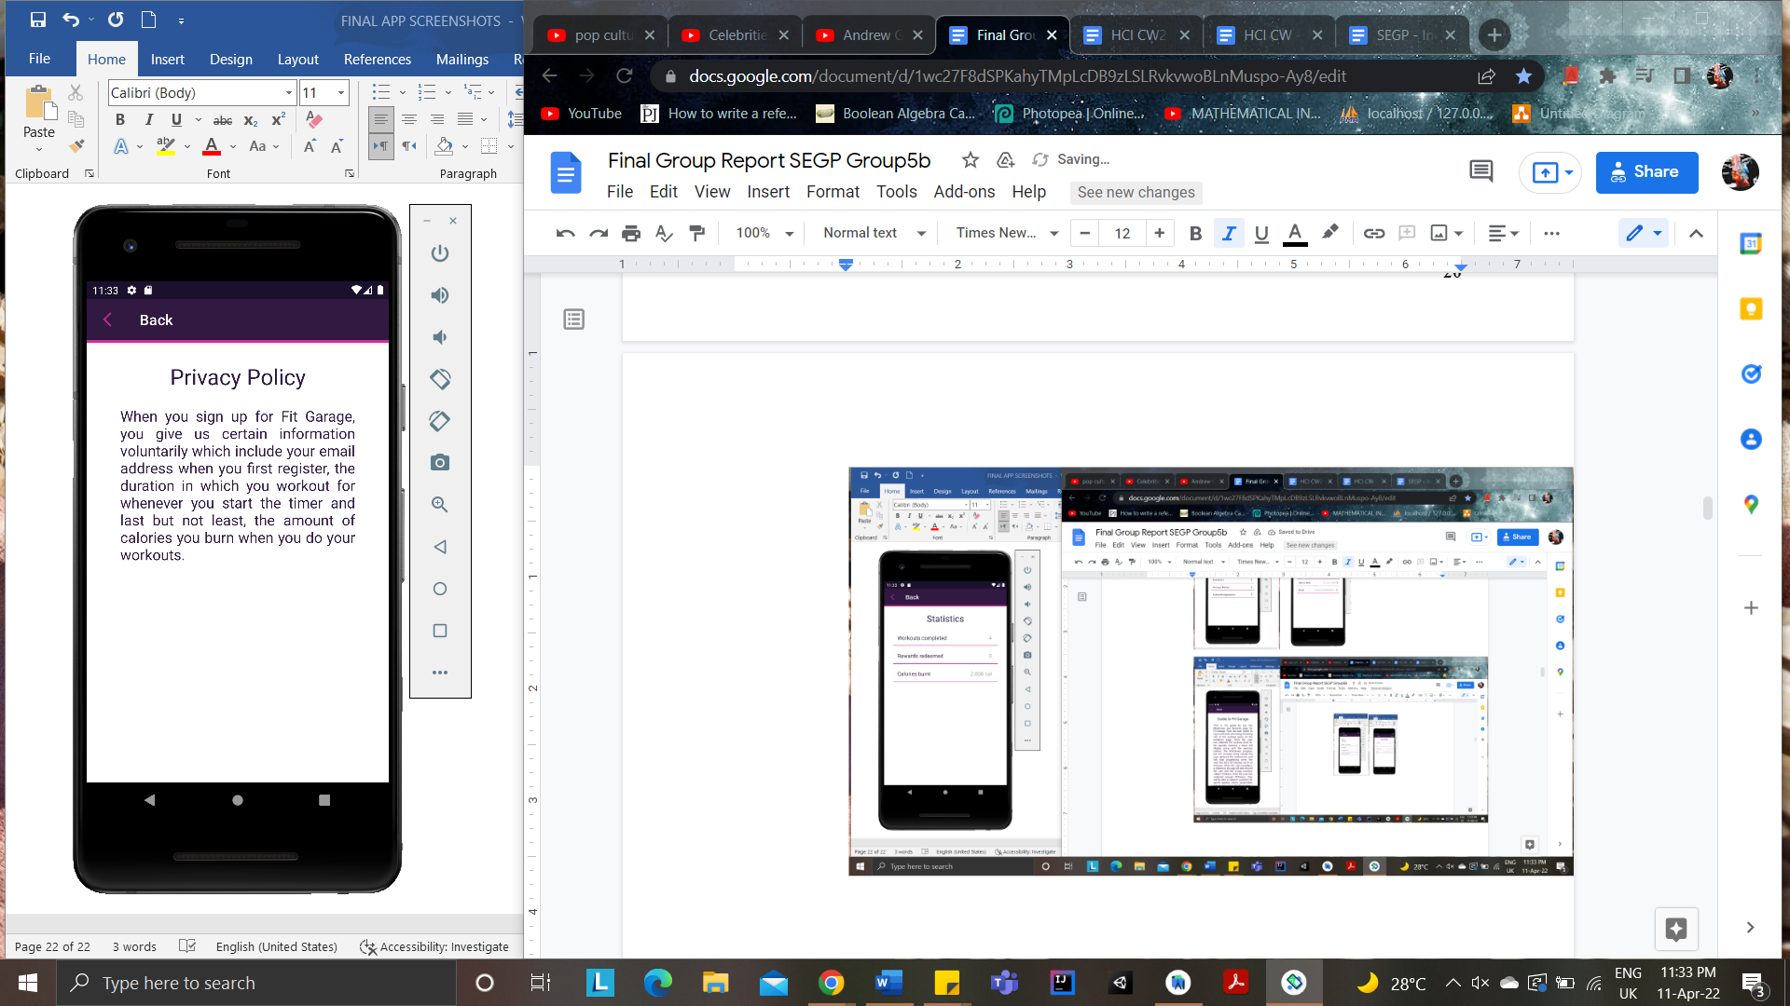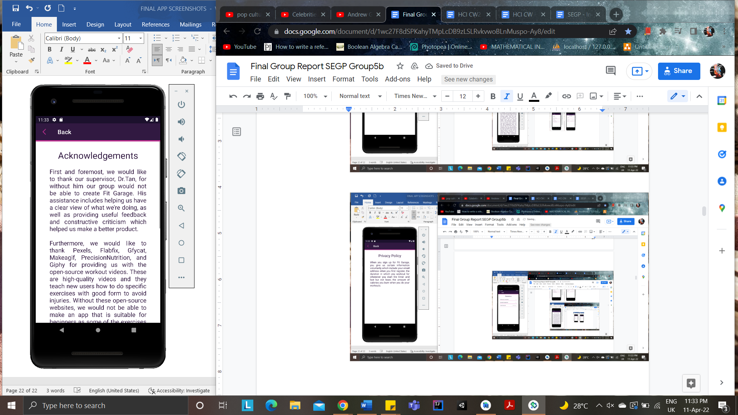

*Privacy Policy page Acknowledgements page*

**Appendix B: Implementation Changes Images**

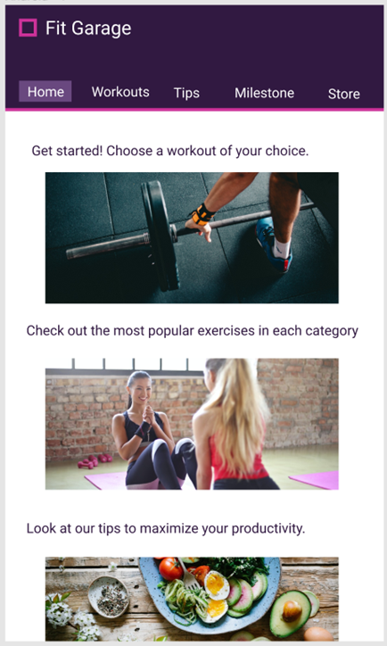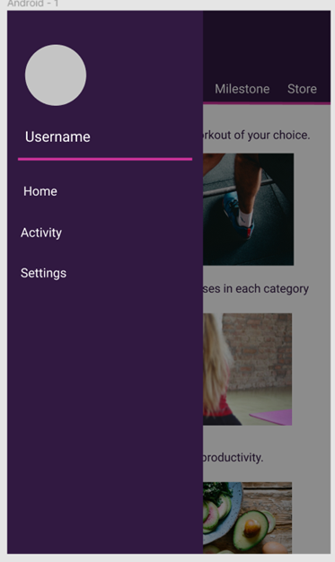  
*Old UX Design 1 Old UX Design 2*

 *New UX Design 1 New UX Design 2*

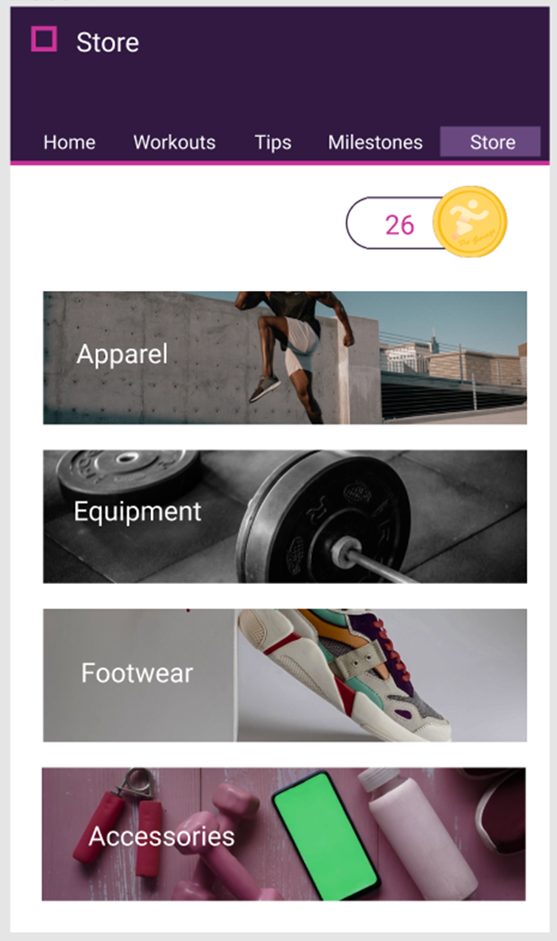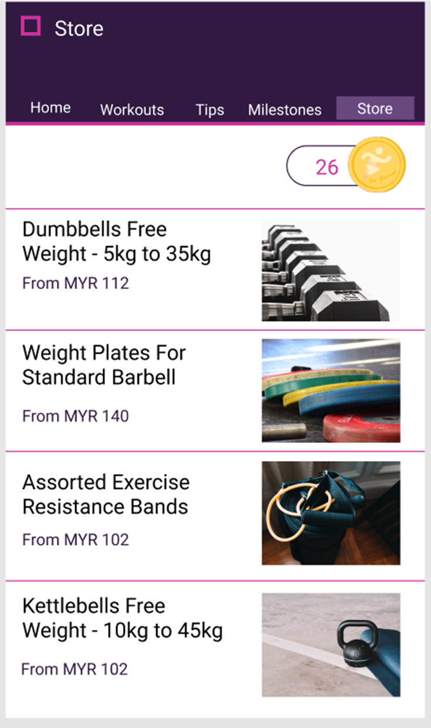  
*Old Store Design 1 Old Store Design 2*

**

*New Store Design*

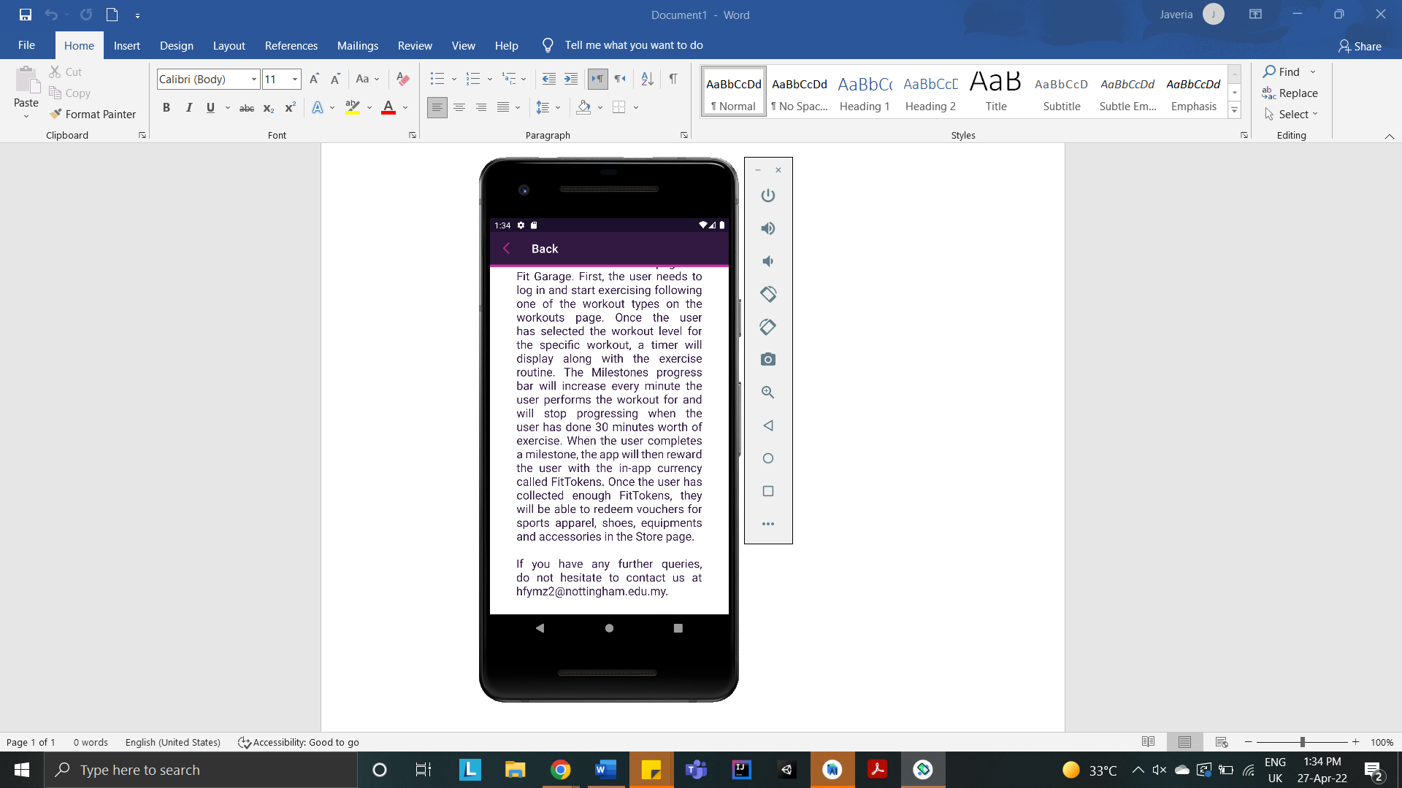  
*Contact information at the bottom, under Guide to Fit Garage section*

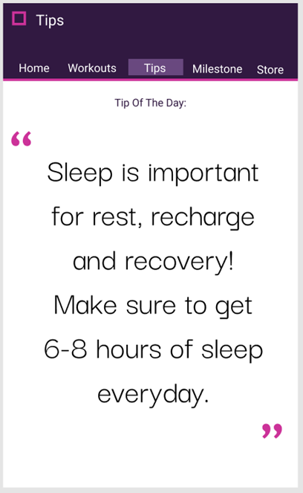   
*Old Tips Design*

**

*New Tips Design 1 New Tips Design 2*

**______________________________________________________________________________**

**Appendix C: User Manual**

**1.0 General Information**

General information section explains in general terms the Fit Garage application overview and the sections of the user manual.

**1.1 Application Overview**

Fit Garage is an Android application for smartphones, where users can improve their physical health by exercising. It also includes tips for users to peruse and rewards for users who workout frequently using the app.

**1.2 Organisation of the Manual**

The user manual consists of the following four sections:

1. General Information
2. System Summary
3. How to download the application
4. Registered Users - Privileges

**2.0 System Summary**

System Summary section explains about the hardware and software requirements for

accessing Fit Garage application and user access levels.

**2.1 Hardware and Software Requirements**

Requires a smartphone with Android operating system (OS).

The minimum Android version should be 4.0.3 and up to avail all the features in the

application.

To download and use the functionalities of Fit Garage smartphone app, you require an

Internet connection on your mobile.

**2.2 User Access Levels**

1. Registered User - registered user is a user who registers themselves in the Fit Garage application by signing up in the registration page.

**3.0 How to download the application**

Fit Garage application can be downloaded through Google Play Store.

**3.1 Google Play Store**

Open Google Play Store on your smartphone device by clicking on the Play Store icon. Click on the search bar and enter ‘Fit Garage’. Click on the Fit Garage application icon from the search result. A page will open which asks to install the application. Click on the "Install" button to install the application.

**4.0 Registered Users - Privileges**

Following features can be availed by a registered user:

-Workout routines

-Research-based tips

-Weekly milestones progress

-In-app rewards

-Vouchers for redemption

**4.1 New User Registration**

A registered user can register in Fit Garage application using the "Sign In" option available in

Registration page. If you are a new user, select “Sign Up” to register. Fill all the

required details and Submit. On successful validation users will be registered, and a welcome email will be sent to the user’s provided email.

**4.2 Sign In**

To Sign In in to the application click on the "Sign In" option from the Registration page. Enter username and password to login. On successful login, the user is redirected to the home page.

**4.3 Workout**

To workout, users can click on the Workout page and select any workout to perform. Upon finishing a workout, their workout details will be stored in Settings, Statistics.

**4.4 Tips**

To read tips, users can click on the Tips page and select any article.

**4.5 Milestones**

To view their weekly milestones, users can click on the Milestones page and view the progress bars indicating their weekly workout minutes.

**4.6 Rewards**

To view their weekly rewards, users can click on the Rewards page and view the rewards they have earned.

**4.7 Store**

To view the store, users can click on the Store button. To redeem a voucher, users can click on the redeem button.

**4.8 Profile Settings**

Users can update their username or email under their profile settings.

**4.9 Log out**

Users can log out from the app by clicking on the log out button in the main menu.

**______________________________________________________________________________**

**Appendix D: Test Suite**

The application was run on Android Studio emulator, and the software’s set of behaviours was validated and verified against the test cases stated in the Test Suite below.

| **Number** | **Action** | **Expected Response** | **Pass/Fail** |
| --- | --- | --- | --- |
| 1 | Click on app icon | Loading screen opens momentarily | Pass |
| Registration page opens | Pass |
| App logo in place | Pass |
| Login button in place | Pass |
| Signup button in place | Pass |
| 2 | Click on Signup button | Signup page opens | Pass |
| App logo in place | Pass |
| Sign Up header in place | Pass |
| Username text in place | Pass |
| Username text box in place | Pass |
| Email text in place | Pass |
| Email text box in place | Pass |
| Password text in place | Pass |
| Password text box in place | Pass |
| Re-Password text in place | Pass |
| Retype Password text box in place | Pass |
| Register button in place | Pass |
| Login redirect button in place | Pass |
| Layout of respective elements consistent | Pass |
| 3 | Click on Username text box | Keyboard opens | Pass |
| Editing is enabled | Pass |
| Username enters upon typing | Pass |
| 4 | Click on Email text box | Keyboard opens | Pass |
| Editing is enabled | Pass |
| Email enters upon typing | Pass |
| 5 | Click on Password text box | Keyboard opens | Pass |
| Editing is enabled | Pass |
| Password enters upon typing | Pass |
| Password characters masked upon typing | Pass |
| 6 | Click on Re-Password text box | Keyboard opens | Pass |
| Editing is enabled | Pass |
| Password enters upon typing | Pass |
| Password characters masked upon typing | Pass |
| 7 | Click on Register button | User cannot register if username already taken | Pass |
| Toast appears if username already taken | Pass |
| User cannot register if email format unacceptable | Pass |
| Toast appears if email format unacceptable | Pass |
| User cannot register if passwords do not match | Pass |
| Toast appears if passwords do not match | Pass |
| User able to sign up succesfully with accurate information | Pass |
| Home page appears on successful sign up | Pass |
| 8 | Click on Login button/Redirect Login button | Login page opens | Pass |
| App logo in place | Pass |
| Login header in place | Pass |
| Username text in place | Pass |
| Username text box in place | Pass |
| Password text in place | Pass |
| Password text box in place | Pass |
| Login button in place | Pass |
| Layout of respective elements consistent | Pass |
| 9 | Click on Username text box | Keyboard opens | Pass |
| Editing is enabled | Pass |
| Username enters upon typing | Pass |
| 10 | Click on Password text box | Keyboard opens | Pass |
| Editing is enabled | Pass |
| Password enters upon typing | Pass |
| Password characters masked upon typing | Pass |
| 11 | Click on Login | User unable to login if user not registered | Pass |
| User unable to login if username not registered | Pass |
| User unable to login if password inaccurate | Pass |
| Toast appears informing user of invalid credentials | Pass |
| User able to login succesfully with accurate information | Pass |
| Home page appears on successful login | Pass |
| 12 | Click on Main Menu Button | Main menu pane appears | Pass |
| App logo in place | Pass |
| App title in place | Pass |
| Home page button in place | Pass |
| Workouts page button in place | Pass |
| Tips page button in place | Pass |
| Milestones page button in place | Pass |
| Store page button in place | Pass |
| Settings page button in place | Pass |
| Log Out button in place | Pass |
| Layout of respective elements consistent | Pass |
| 13 | Click on Home under Main Menu | Home page opens | Pass |
| Images in place | Pass |
| Text in place | Pass |
| 14 | Click on image button 1 on Home page | Workouts main page opens | Pass |
| 15 | Click on image button 2 on Home page | Store page opens | Pass |
| 16 | Click on image button 3 on Home page | Tips page opens | Pass |
| 17 | Click on Workouts under Main Menu | Workouts main page opens | Pass |
| Main menu button in place | Pass |
| Workouts heading in place | Pass |
| Instructional text in place | Pass |
| Appropriate image buttons in place | Pass |
| 18 | Click on image buttons on Workouts page | Back button in place | Pass |
| Body section name title in place | Pass |
| Instructional text in place | Pass |
| Beginner button in place | Pass |
| Intermediate button in place | Pass |
| Advanced button in place | Pass |
| Layout of respective elements consistent | Pass |
| 19 | Click on any difficulty level button | Respective workout routine appears | Pass |
| Back button in place | Pass |
| End workout button in place | Pass |
| Workout title in place | Pass |
| Video Player in place | Pass |
| Instructional text in place | Pass |
| Unstarted Timer clock in place | Pass |
| Start button in place | Pass |
| 20 | Click on Start | Respective workout routine starts | Pass |
| Back button in place | Pass |
| End Workout button in place | Pass |
| Video player with respective instructional video playing in place | Pass |
| Workout title in place | Pass |
| Exercise title in place | Pass |
| Exercise duration in place | Pass |
| Started Timer clock in place | Pass |
| Next button in place | Pass |
| Layout of respective elements consistent | Pass |
| 21 | Click on Next | Next exercise in workout routine starts | Pass |
| Back button in place | Pass |
| End Workout button in place | Pass |
| Video player with respective instructional videos playing in place | Pass |
| Workout title in place | Pass |
| Exercise title in place | Pass |
| Exercise duration in place | Pass |
| Continuing Timer clock in place | Pass |
| Next button in place | Pass |
| Layout of respective elements consistent | Pass |
| 22 | Click on End Workout/Finish Workout | Completed Workout page appears | Pass |
| Exit button in place | Pass |
| Workout title in place | Pass |
| Appropriate image in place | Pass |
| Time Taken information text in place | Pass |
| Time taken calculation text in place | Pass |
| Time taken calculation accurate | Pass |
| Calories text in place | Pass |
| Calories calculation text in place | Pass |
| Calories calculation accurate | Pass |
| Exit button in place | Pass |
| 23 | Click on Exit button | Finished workout’s body section’s workout difficulty level page appears | Pass |
| Back button in place | Pass |
| Body section name title in place | Pass |
| Instructional text in place | Pass |
| Beginner button in place | Pass |
| Intermediate button in place | Pass |
| Advanced button in place | Pass |
| 24 | Click on back button | Workouts main page opens | Pass |
| Main menu button in place | Pass |
| Instructional text in place | Pass |
| Appropriate image buttons in place | Pass |
| 25 | Click on Main Menu button | Main menu pane appears | Pass |
| Appropriate buttons in place | Pass |
| 26 | Click on Tips button | Tips main page opens | Pass |
| Main menu button in place | Pass |
| Tips heading in place | Pass |
| Appropriate images in place | Pass |
| Scrolling functional | Pass |
| 27 | Click on any Tips article | Respective tips page opens | Pass |
| Back button in place | Pass |
| Tips title in place | Pass |
| Subheadings in place | Pass |
| Text bodies in place | Pass |
| Respective images in place | Pass |
| Appropriate colours assigned to respective elements | Pass |
| 28 | Click on Back button | Tips main page opens | Pass |
| Main menu button in place | Pass |
| Tips heading in place | Pass |
| Appropriate images in place | Pass |
| Scrolling functional | Pass |
| 29 | Click on Main Menu button | Main menu pane with all appropriate elements opens | Pass |
| 30 | Click on Milestones button | Milestones page opens | Pass |
| Main menu button in place | Pass |
| Milestones heading in place | Pass |
| All days of week’s names’ text in place | Pass |
| All days of week’s respective progress bars in place | Pass |
| Minute count text in place | Pass |
| Minute count calculation accurate | Pass |
| Rewards button in place | Pass |
| 31 | Click on Rewards button | Rewards page opens | Pass |
| Back button in place | Pass |
| Rewards heading in place | Pass |
| All days of week’s names’ text in place | Pass |
| FitToken text in place | Pass |
| FitToken received buttons in place | Pass |
| FitToken received buttons functional based on user’s progress in Milestones | Pass |
| Bonus FitTokens’ count text in place | Pass |
| Bonus FitTokens’ received buttons in place | Pass |
| Bonus FitTokens’ buttons functional based on user’s consistent progress in Milestones | Pass |
| 32 | Click on Back button | Milestone page opens | Pass |
| 33 | Click on Main Menu button | Main menu pane with all appropriate elements opens | Pass |
| 34 | Click on Settings | Settings page opens | Pass |
| Settings header in place | Pass |
| Current username in place | Pass |
| Edit profile button in place | Pass |
| Guide button in place | Pass |
| Statistics button in place | Pass |
| Acknowledgements button in place | Pass |
| Layout of respective elements consistent | Pass |
| 35 | Click on Edit Profile | Edit Profile page opens | Pass |
| Edit Profile heading in place | Pass |
| Back button in place | Pass |
| Save button in place | Pass |
| Username text in place | Pass |
| Username in place | Pass |
| ID text in place | Pass |
| ID number in place | Pass |
| Date of Birth text in place | Pass |
| Date of birth in place | Pass |
| Email text in place | Pass |
| Email in place | Pass |
| Layout of respective elements consistent | Pass |
| 36 | Click on Username | Keyboard opens | Pass |
| Editing is enabled | Pass |
| Username Updates upon change | Pass |
| 37 | Click on ID | No action | Pass |
| 38 | Click on Date of Birth | Scrolling Date pop-up appears | Pass |
| Changing date enabled | Pass |
| Date updates on change | Pass |
| 39 | Click on Email | Keyboard opens | Pass |
| Editing is enabled | Pass |
| Email updates upon change | Pass |
| 40 | Click on Save button | Confirmation dialogue box appears | Pass |
| Instructional text in place | Pass |
| Appropriate buttons in place | Pass |
| 41 | Click on Cancel | Updated information is not saved | Pass |
| 42 | Click on Confirm | Updated information saves upon clicking | Pass |
| Toast appears informing user of updated information | Pass |
| 43 | Click on Back button | Settings main page appears | Pass |
| Appropriate elements consistent and in place | Pass |
| 44 | Click on main menu button | Main menu pane with all appropriate elements opens | Pass |
| Layout of respective elements consistent | Pass |
| 45 | Click on Log Out | User successfully logs out | Pass |
| Toast appears informing user of successful log out | Pass |
| Registration page appears | Pass |
| App logo in place | Pass |
| Sign Up button in place | Pass |
| Log In button in place | Pass |
| Sign Up button functional | Pass |
| Login button functional | Pass |

**Appendix E: Meeting Overview**

| **1** | **Date:**  **23/12/2021** | **Type:**  **Informal** | **Formal Attendees:**  **Group members** |
| --- | --- | --- | --- |
|  | -Objective:  To review the fundamental implementations of the app’s coding.  -Discussion:  The meeting focused on the base designs implemented by the group members in Android Studio. Here are the key points:   * Group members created and reviewed the basic skeleton of the app. This included activity pages, text, images and some design elements. * Group members discussed limitations regarding the usage of the app and assisted fellow members in any doubts regarding the navigation of Android Studio. * Further strategies were discussed on how to improve and/or initiate coding to improve on the basic layout of the app already implemented. * Based on the reviews, group members further segregated the tasks into more detailed exercises and assigned them to various members, keeping in mind the members’ strengths and comfort with respect to the task they were assigned. * Discussion was also held regarding external communication and approval of a company concerning our team’s request to make non-monetary and educational usage of their video material for our app. | | |
| **2** | **Date:**  **03/01/2022** | **Type:**  **Informal** | **Formal Attendees:**  **Group members** |
|  | -Objective:  To further review the fundamental implementations of the app’s coding.  -Discussion:  The meeting focused on features and additions made to the base designs implemented by the group members in Android Studio. Here are the key points:   * Base design and layout was applied to every activity created thus far in our app. * Initial skeleton was improved and built upon, and app was coded to change pages/activities upon interaction with images and buttons. * Group members reviewed improvements made regarding initial challenges faced in the navigation of Android Studio, and communicated with each other to suggest solutions to common problems. * Contents of all functionalities were revised again in brief details, while giving more attention to the importance of pages with primary functionality, as well as secondary functionalities. * Discussion was held regarding the progress of locating appropriate open source visual media from the previously approved website. | | |
| **3** | **Date:**  **24/01/2022** | **Type:**  **Informal** | **Formal Attendees:**  **Group members** |
|  | -Objective:  To review the more detailed implementations of the app’s coding.  -Discussion:  The meeting focused on the features and additions made to the designs implemented by the group members in Android Studio. Here are the key points:   * Group members further discussed the segregation of app’s functionalities into more detailed tasks and distributed workload appropriately to each member of the group. * Details regarding the functionality of the app and each page of its activity was thoroughly discussed to ensure smooth development of the app. | | |
| **4** | **Date:**  **07/02/2022** | **Type:**  **Informal** | **Formal Attendees:**  **Group members** |
|  | -Objective:  To further review the more detailed implementations of the app’s coding.  -Discussion:  The meeting focused on the additions made to the features and designs implemented by the group members in Android Studio. Here are the key points:   * Group members discussed and reviewed the progress of the Login page and Sign-up page. * The basic development of Milestones and Rewards pages was discussed and assessed for further development. * The final layout and new strategy for the Tips page was considered and approved. * Group members inquired about the Workout page and stressed the importance of the primary functionality of the app. * Short discussion was held regarding the content of the next meeting. * Group members stressed and discussed the timeline of our project. | | |
| **5** | **Date:**  **14/02/2022** | **Type:**  **Informal** | **Formal Attendees:**  **Group members** |
|  | -Objective:  To combine the coding tasks delegated to each member of the group.  -Discussion:  The meeting focused on reviewing the work of team members and combining the code into a singular file. Here are the key points:   * Each team member discussed their progress and informed the group about the status of their work, in order to ensure that all team members knew the progression of each member and that the group was updated and in sync. * Different tasks of coding that had been assigned to various team members were combined into a singular, functioning file and uploaded to GitHub. * Comments and feedback was given with respect to group members’ work during project reviewing. * Team members were encouraged to update their own projects by including the other members’ progress, to ensure that every member was updated and had the same functioning version of the app. * Team members discussed in thorough details the stages of their tasks, their successes and limitations. * Alleviation of said limitations was considered and approved through task redistributions. * Importance of certain functionalities of the app were stressed and project timeline rediscussed. * A document of the Final Group Report was created and started. * A document of Presentation was created. | | |
| **6** | **Date:**  **18/02/2022** | **Type:**  **Formal** | **Formal Attendees:**  **Dr Chong Siang Yew, Dr Tan Chye Cheah, Muhammad Hanz Affiq Bin Zuki,  Wei, Zhenyang, Aaron Tan Tai Ping, Javeria Zahid** |
|  | -Objective:  To introduce our project to our new supervisor, and maintain discussion with our former Supervisor.  -Discussion:  The meeting focused on introducing, presenting and discussing our project with our new Supervisor, whilst updating and reviewing our progress with our former Supervisor. Here are the key points:   * The project of our app was summarised and group members relayed the primary functionality and secondary functionalities to the new Supervisor. * Progress of our app was talked about, with attention given to the timeline depicted in the team’s Interim Report. New Supervisor and team members had detailed discussion about the current timeline of the project, and New Supervisor stressed on the importance of the app’s main functionality and suggested to the team to bring their efforts and focus on delivering an operative main functionality first. * Additionally, New Supervisor also stressed on the importance of frequent software testing. * New Supervisor inquired about the tasks delegated to each member of the group, the general group organisation methodology, the frequency of the team’s meetings and formal communications, the basis of task distribution, and any limitations in terms of progress in regard to the team. * Team members presented certain queries regarding different aspects of the project, which were clarified by both Supervisors. * Minor discussion was held concerning a few limitations pertaining to the app and the project. * Supervisors conveyed suggestions for certain areas which would improve the progress of the project, and group members took these into consideration. | | |
| **7** | **Date:**  **21/02/2022** | **Type:**  **Informal** | **Formal Attendees:**  **Group members** |
|  | -Objective:  To review the progress of the primary functionality of the app.  -Discussion:  The meeting focused on developing and reviewing the coding of the primary functionality of the app, while maintaining the progress of the ongoing secondary functionalities. Here are the key points:   * All group members were informed and updated on the change in supervisor, as well as key points and details of the previous meeting. * Group members reviewed the page with primary functionality (workout page) and delivered feedback, criticism and key details of the procedural properties of the workout page. * Group members stressed on the importance of primary functionality and issued a reminder to have the first working version of the app by a certain deadline. * The details of the workout page and flow of exercise routines were revised. * Group members also reviewed the progress regarding the combining of different pages within the Android Studio platform completed so far by various members of the group. * The progression of secondary functionality (Milestone and Rewards page) was further discussed, and team members relayed the challenges faced in implementing certain features in regard to said page. * Group members suggested alternatives and how to proceed in face of coding obstacles to members facing difficulties. | | |
| **8** | **Date:**  **25/02/2022** | **Type:**  **Informal** | **Formal Attendees:**  **Group members** |
|  | -Objective:  To review the progress of the primary functionality of the app.  -Discussion:  The meeting focused on developing and reviewing the coding of the primary functionality of the app, while maintaining the progress of the ongoing secondary functionalities. Here are the key points:   * Group members discussed the progress of the Store page, and feedback was delivered by the team. * Group members reviewed further additions in detail regarding the tracking of FitTokens, which are crucial to the Milestones and Rewards page, as well as the progression of the Milestones and Rewards page as a whole. * Workout page was thoroughly reviewed and feedback was given on the progress of the page thus far. * Group members meticulously discussed every element of the Workout page, in addition to the timer in regard to the duration of the workout, implementation details as well as the calculations involved with respect to workout details. | | |
| **9** | **Date:**  **28/02/2022** | **Type:**  **Informal** | **Formal Attendees:**  **Group members** |
|  | -Objective:  To review the progress of the primary functionality of the app.  -Discussion:  The meeting focused on developing and reviewing the coding of the primary functionality of the app, while maintaining the progress of the ongoing secondary functionalities. Here are the key points:   * Group members confirmed the completion of the Store page. * Group members also discussed the final details required concerning the completion of the Milestones and Rewards pages. * The first functional progress of the Workout page was reviewed. The fundamental code was shared with other appropriate group members to further build upon. * Full evaluation and detailed discussion was done on the progress thus far and the next steps in regards to the Workout page. * Brief, but thorough feedback was given by group members to the different app pages reviewed * Group members evaluated the current progress and considered the pages completed so far to ensure no page or activity was left incomplete. Appropriate tasks were assigned to ensure this. * Short discussion was held regarding the next steps to complete in our schedule. | | |
| **10** | **Date:**  **02/03/2022** | **Type:**  **Informal** | **Formal Attendees:**  **Group members** |
|  | -Objective:  To review the progress of the primary functionality of the app.  -Discussion:  The meeting focused on developing and reviewing the coding of the primary functionality of the app, while maintaining the progress of the ongoing secondary functionalities. Here are the key points:   * Group members confirmed the completion of the secondary functionalities: the Milestones and Rewards pages. * Group members also started creating workout routine pages for various body parts, utilising the functioning workout code created and discussed in the previous meeting. | | |
| **11** | **Date:**  **06/03/2022** | **Type:**  **Informal** | **Formal Attendees:**  **Group members** |
|  | -Objective:  To review the progress on the primary functionality of the app.  -Discussion:  The meeting focused on developing and reviewing the coding of the primary functionality of the app, while also developing user information functionalities of the app. Here are the key points:   * Group members updated on the positive progress of the sectionalized body parts’ workout page. * Group members discussed the first working prototype of the workout page, and how to utilise it for other body parts’ workout sections as well. * Discussion was held regarding the limitations in the coding progression due to different types of database recommendations for different pages (namely Registration pages and Edit Profile pages) within the app. * Follow-up discussion was held involving strategies to overcome obstacles caused by said database limitation. * Group members finalised by recommending that any last confusion be discussed with the supervisor for clarity. | | |
| **11** | **Date:**  **08/03/2022** | **Type:**  **Informal** | **Formal Attendees:**  **Group members** |
|  | -Objective:  To review the progress on the primary functionality of the app.  -Discussion:  The meeting focused on developing and reviewing the coding of the primary functionality of the app, while also developing user information functionalities of the app. Here are the key points:   * Group members discussed the details of the limitations faced on the user information section of the app. * Group members offered alternative solutions which were tested. * Upon negative results, group members agreed on discussing this further and to enquire about any additional difficulties from the Supervisor. * Group members rescheduled the reviewing of the Workout section of the app. | | |
| **12** | **Date:**  **09/03/2022** | **Type:**  **Informal** | **Formal Attendees:**  **Group members** |
|  | -Objective:  To review the progress on the primary functionality of the app.  -Discussion:  The meeting focused on developing and reviewing the coding of the primary functionality of the app, while also developing user information functionalities of the app. Here are the key points:   * Group members reviewed the progress of the Milestone and Rewards page, as well as the Workout page, in a thorough manner. * Group members approved of the progress of the Milestones, Rewards, and Workout page. * Certain challenges and errors were discussed within the Workout page. * The Edit Profile page was analysed after exchanging potential solutions via text messaging. * Group members decided to create one working demo for a body part’s working routine. * Group members also recommended sharing the entire project progress on GitHub for every team member to access. * In addition, group members assigned one singular team member to compile all working progress of the app into one functioning file, as well as to upload any progress to GitHub. | | |
| **13** | **Date:**  **10/03/2022** | **Type:**  **Informal** | **Formal Attendees:**  **Group members** |
|  | -Objective:  To review the progress on the primary functionality of the app.  -Discussion:  The meeting focused on developing and reviewing the coding of the primary functionality of the app. Here are the key points:   * Group members thoroughly researched and implemented coding for the workout routine flow. * Group members also implemented the elements required in the pages to ensure the pages were functional, and noted any limitations. * The demo of one body part workout routine was reviewed and approved. * The demo’s implementation was stated to serve as the blueprint code to implement the rest of the body parts’ workout routines. | | |
| **14** | **Date:**  **11/03/2022** | **Type:**  **Formal** | **Formal Attendees:**  **Group members and Dr Tan Chye Cheah** |
|  | -Objective:  To discuss the app’s progress with the Supervisor.  -Discussion:  The meeting focused on discussing the progress of the app with the Supervisor, to glean his feedback and clear inquiries. Here are the key points:   * Group members presented the entire app to the supervisor. * Subsequently, group members gathered feedback on various elements of the app from the supervisor’s review of the app. * Group members discussed the requirements’ gathering with the supervisor. * Supervisor recommended new suggestions for the app. This included new features. * Group members reviewed the project timeline and stressed the importance of current functionalities. * Supervisor agreed on group members’ decision on focusing on current functionalities. * Group members, regardless, agreed to research further on the supervisor’s suggested features’ tips. | | |
| **14.1** | **Date:**  **11/03/2022** | **Type:**  **Informal** | **Formal Attendees:**  **Group members** |
|  | -Objective:  To discuss the feedback of the Supervisor.  -Discussion:  The meeting focused on dissecting and discussing the feedback given by the Supervisor, and how to go about our next steps. Here are the key points:   * Group members reviewed the procedure of the workout page in the app. * Group members assigned each body part to various group members to complete based on the ‘blueprint’ for the workout page already completed. * A thorough discussion on how to implement a calorie tracker based on the user's workout data. * Discussion was also held on how to improve the user-friendly aspect of the workout routine in terms of data display. | | |
| **15** | **Date:**  **16/03/2022** | **Type:**  **Informal** | **Formal Attendees:**  **Group members** |
|  | -Objective:  To review the progress of the app as a whole.  -Discussion:  The meeting focused on developing and reviewing the coding of the various elements within the app. Here are the key points:   * Group members discussed the completion of body part’s workouts of all levels. * Group members also discussed the Milestones page, and the different requirements needed, such as database requirements and connection to the internet. * A discussion was held regarding the next steps in order to have a fully functional app. | | |
| **16** | **Date:**  **18/03/2022** | **Type:**  **Informal** | **Formal Attendees:**  **Group members** |
|  | -Objective:  To review the progress of the app as a whole.  -Discussion:  The meeting focused on developing and reviewing the coding of the various elements within the app. Here are the key points:   * A discussion was held regarding the full completion of workout pages with all members. * Group members informed everyone to compile all working progress with appropriate group members. * Group members discussed any limitations faced with the Analytics page. * Group members made note of items of discussion for the upcoming meeting with the supervisor. | | |
| **17** | **Date:**  **23/03/2022** | **Type:**  **Informal** | **Formal Attendees:**  **Group members** |
|  | -Objective:  To review the progress of the app as a whole.  -Discussion:  The meeting focused on developing and reviewing the coding of the various elements within the app. Here are the key points:   * Group members discussed the Milestones page and the implementation of the account system in relation to the Milestone and Rewards page. * Group members discussed the progress and compilation of different tasks done by various group members. * Group members reviewed the list of items that were to be discussed in the upcoming meeting with the supervisor. | | |
| **18** | **Date:**  **25/03/2022** | **Type:**  **Informal** | **Formal Attendees:**  **Group members** |
|  | -Objective:  To review the progress of the app as a whole.  -Discussion:  The meeting focused on developing and reviewing the coding of the various elements within the app. Here are the key points:   * Group members discussed the progression and completion of the Milestones page. * Group members also reviewed the Milestones page, in addition to the progress on the user account system. * Discussed the next steps to ensure all elements of the app are functional, as well as complete. * Informed all group members to research on appropriate topics. | | |
| **19** | **Date:**  **25/03/2022** | **Type:**  **Formal** | **Formal Attendees:**  **Dr Tan Chye Cheah and Group members** |
|  | -Objective:  To discuss enquiries with the Supervisor.  -Discussion:  The meeting focused on discussing enquiries faced in regards to the implementation of the app, and to get insight, clarification and suggestions from the Supervisor. Here are the key points:   * Group members enquired about the obstacles faced in the implementation of the account system. * Supervisor suggested using a date and time system to overcome an obstacle in the Milestones page’s system. * Supervisor clarified on one of the misunderstandings in their suggestion. * Supervisor also enquired about the limitations with the current account system, * Supervisor enquired about the depth of the emulation of the Store page. * Subsequently, the Supervisor suggested how to alternatively implement some features of the Store. * Group members and Supervisor clarified different parts of the app. | | |
| **20** | **Date:**  **28/03/2022** | **Type:**  **Informal** | **Formal Attendees:**  **Group members** |
|  | -Objective:  To review the progress of the app as a whole.  -Discussion:  The meeting focused on developing and reviewing the coding of the various elements within the app. Here are the key points:   * Group members discussed the Rewards Page’s completion. * Group members reviewed an alternate completed version of the Rewards Page. * The process of resetting the Milestones page on a weekly basis was discussed. * Changes to be made in the Store page were discussed, as well as how to include the FitTokens based on a user’s rewards within the Store page. * Group members discussed the elements of the Settings page and discussed the elements completed, elements to be completed and elements in progress. * Group members decided on combining the main Milestones implementation with the alternate Milestone implementation. * Group members discussed the new idea of utilising vouchers for the Store page. | | |
| **21** | **Date:**  **30/03/2022** | **Type:**  **Informal** | **Formal Attendees:**  **Group members** |
|  | -Objective:  To review the progress of the app as a whole.  -Discussion:  The meeting focused on developing and reviewing the coding of the various elements within the app. Here are the key points:   * Group members discussed the combining of Milestones page and Rewards page. * Group members discussed the progression of the Store page. * Group members discussed the completion of the Statistics page. | | |
| **22** | **Date:**  **01/04/2022** | **Type:**  **Informal** | **Formal Attendees:**  **Group members** |
|  | -Objective:  To review the progress of the app as a whole.  -Discussion:  The meeting focused on developing and reviewing the coding of the various elements within the app. Here are the key points:   * Group members discussed the progress of the Store page. * Group members discussed ideas on how to reset the Rewards page on a weekly basis. * Group members reviewed the Statistics page. * Group members discussed briefly on how many FitTokens to assign per voucher in the Store page. * Group members also had a brief discussion on the processes to occur upon a voucher redemption. | | |
| **23** | **Date:**  **06/04/2022** | **Type:**  **Informal** | **Formal Attendees:**  **Group members** |
|  | -Objective:  To review the progress of the app as a whole.  -Discussion:  The meeting focused on developing and reviewing the coding of the various elements within the app. Here are the key points:   * Group members discussed reviewing the Store page. * Group members perused a list of solutions regarding the weekly reset on Rewards page. * Group members discussed the contents and progress of the presentation and final report. | | |
| **24** | **Date:**  **08/04/2022** | **Type:**  **Informal** | **Formal Attendees:**  **Group members** |
|  | -Objective:  To review the progress of the app as a whole.  -Discussion:  The meeting focused on developing and reviewing the coding of the various elements within the app. Here are the key points:   * Group members discussed the completion of the Store page. * The app was run and every page was interacted with, and checked thoroughly to ensure all components were functioning as required. * Group members discussed the progress on the weekly reset of Rewards page. * Group members decided to add an extra feature within the app for users to contact the app admins for extra inquiries. * Group members reviewed the progress and contents of the presentation. | | |
| **25** | **Date:**  **13/04/2022** | **Type:**  **Informal** | **Formal Attendees:**  **Group members** |
|  | -Objective:  To rehearse for demo day.  -Discussion:  The meeting focused on reviewing the group project presentation and rehearsing for demo day. Here are the key points:   * Group members reviewed the progress of the presentation * Group members discussed areas of improvement for the presentation. | | |
| **26** | **Date:**  **15/04/2022** | **Type:**  **Informal** | **Formal Attendees:**  **Group members** |
|  | -Objective:  To rehearse for demo day.  -Discussion:  The meeting focused on reviewing the group project presentation and rehearsing for demo day. Here are the key points:   * Group members discussed areas of improvement for the presentation. * Group members discussed recording a backup of the demo. | | |
| **27** | **Date:**  **18/04/2022** | **Type:**  **Informal** | **Formal Attendees:**  **Group members** |
|  | -Objective:  To rehearse for demo day.  -Discussion:  The meeting focused on reviewing the group project presentation and rehearsing for demo day. Here are the key points:0   * Discussed the progress on the presentation. * Discussed the progress on recording of back-up for demo day. | | |

**________________________________________________________________________**

**Appendix F: Project Diagrams**

**i.Use Case Diagram**

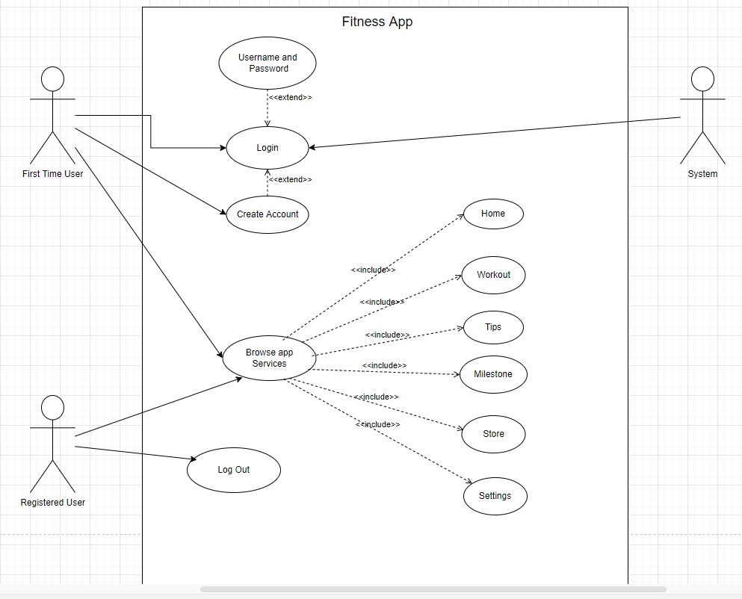

**ii. Activity Diagram**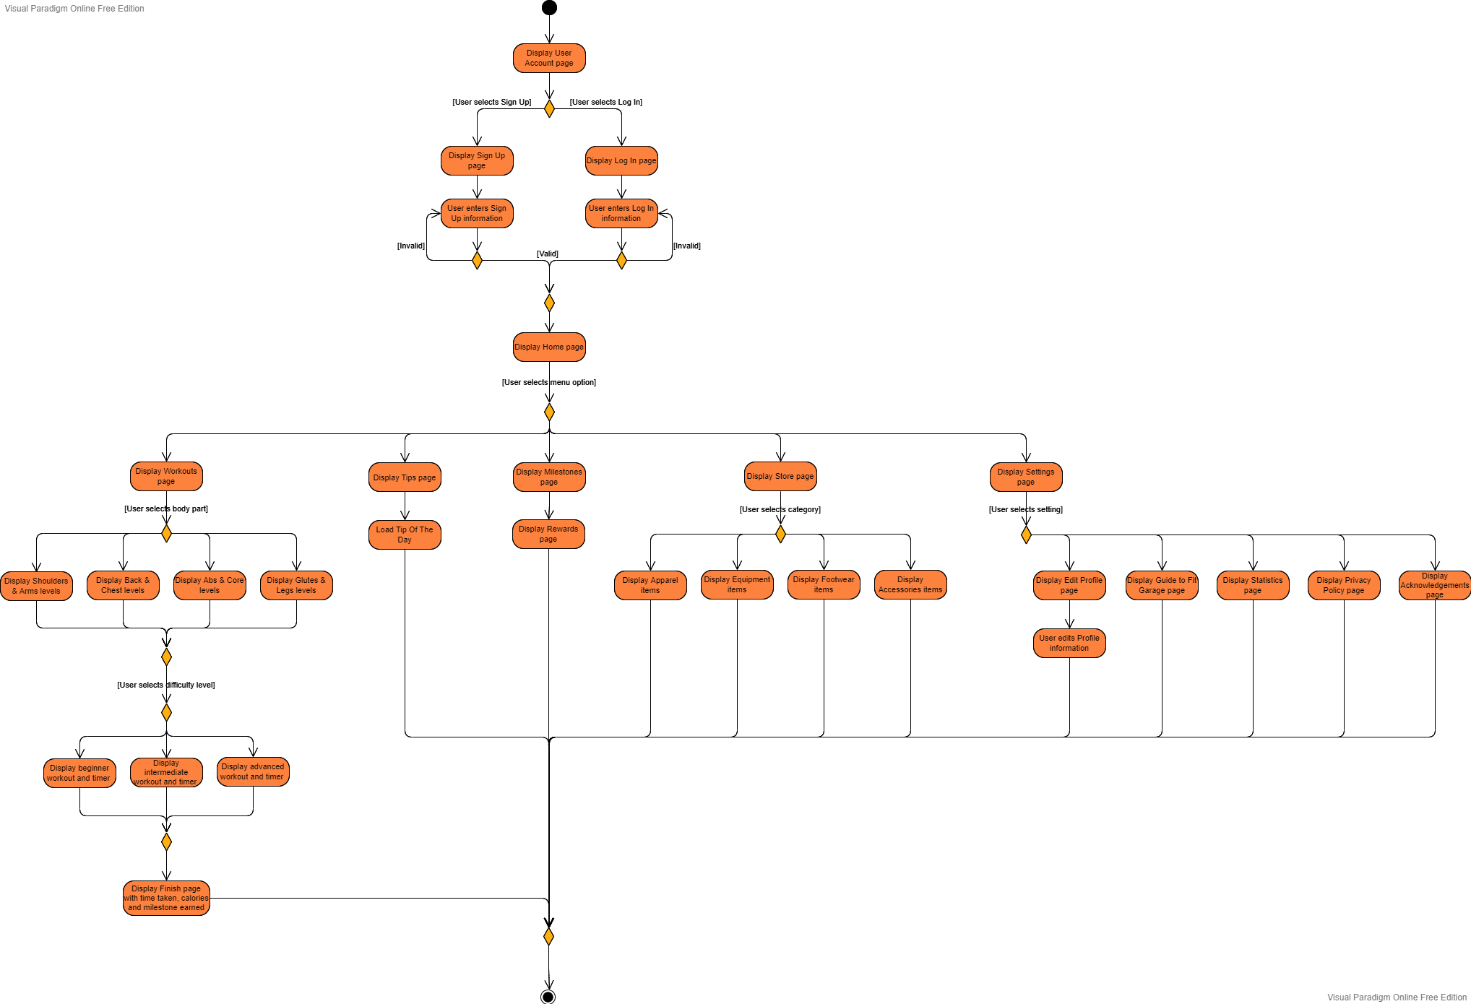

**iii. Sequence Diagram**

**a.Login Page**

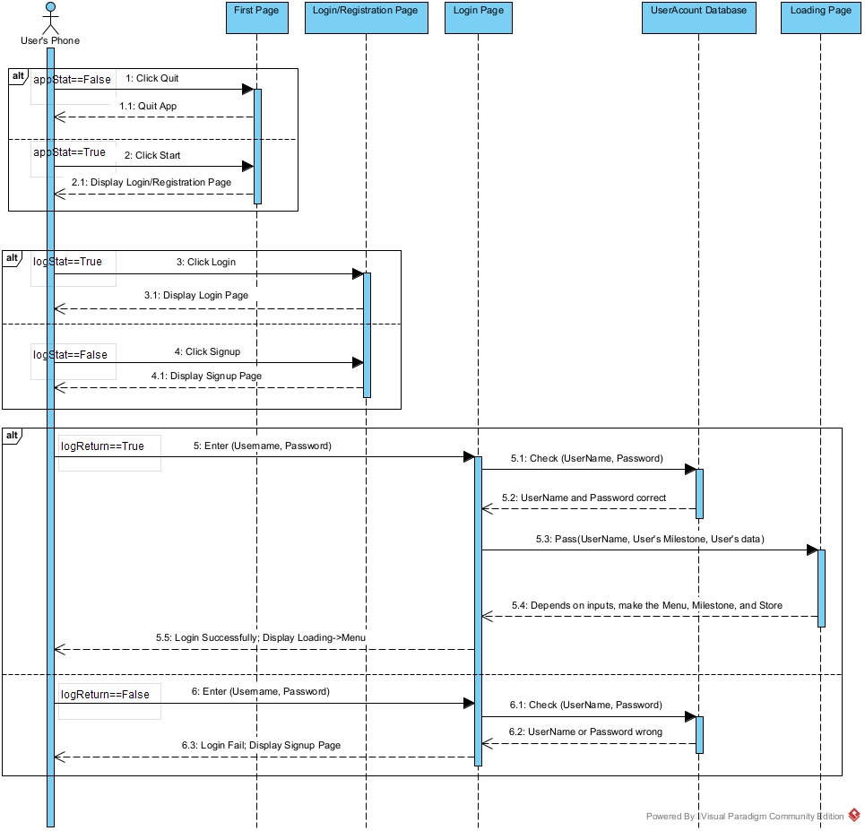

**b. Main Menu**

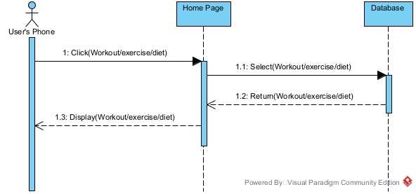

**c. Workout Page**

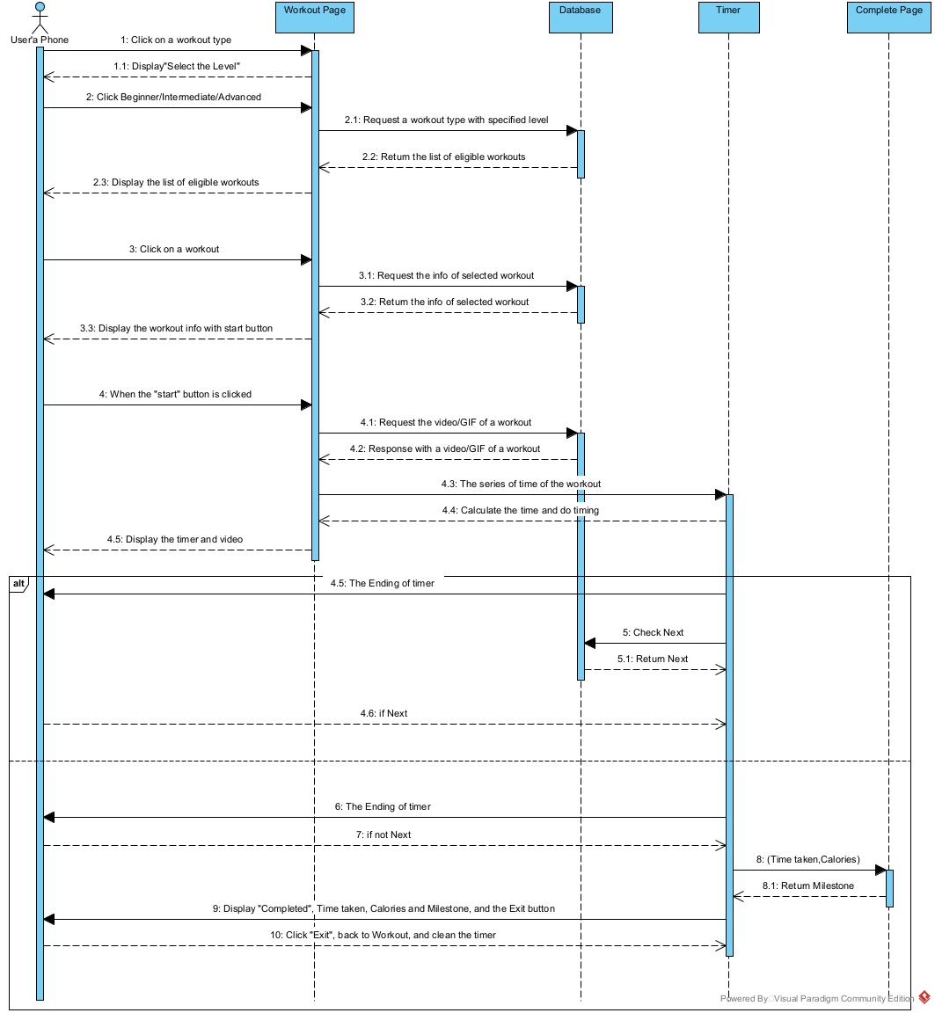

**d. Store Page**

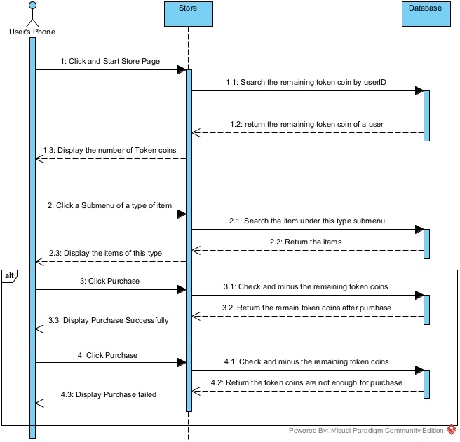

**e. Milestone Page**

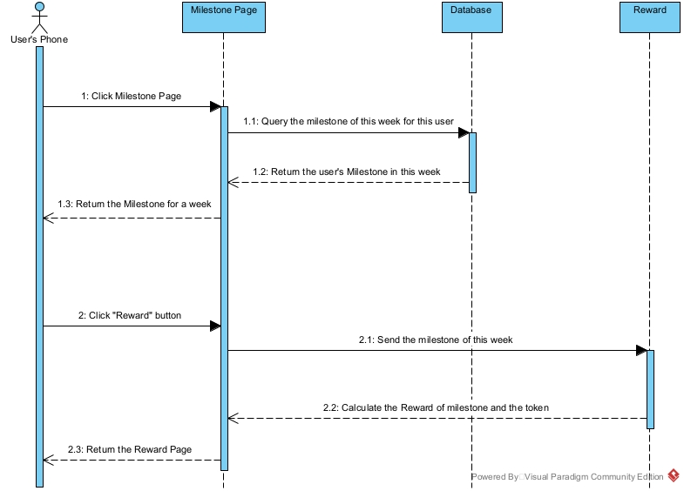

**g. Settings Page**

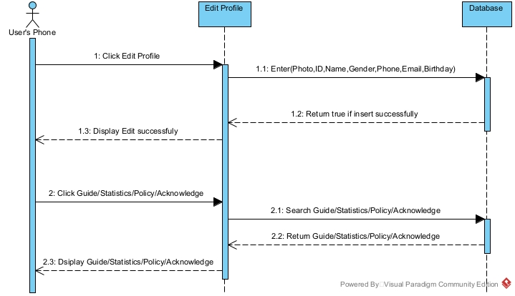

**iv. Class Diagram**

